Stephen Paul Borne
June 29, 1967 – February 11, 2017

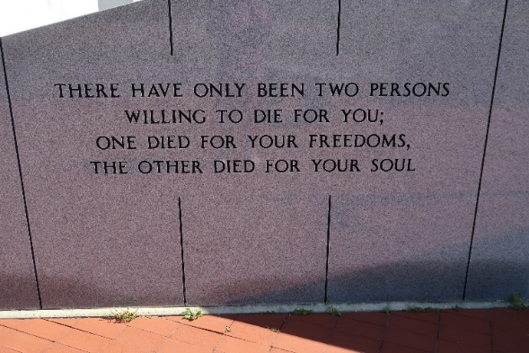

A resident of Vacherie, he passed away the morning of Saturday, February 11, 2017 at the age of 49.
He was the beloved father of Anna Marie Borne and Andrea Michelle Borne. The son Roy and Sylvia Borne. The brother of Stephanie Collins and spouse Emile Collins. The uncle of Lee Schexnayder and great uncle of Maddux Schexnayder. The finance' of Peggy Dalon. He was loved by aunts, uncles, cousins and friends. He is proceeded in death by his paternal grandparents Roy and Stephanie Borne and his maternal grandparents Daniel Reid, Sr. and Jeanne Folse, and Godson Lorne Schexnayder, Jr.
He was a 1986 graduate of St. James High School. He went to culinary school in Baton Rouge. He finished is culinary career in his hometown as the Executive Chef for BandC Seafood on the river.
He was always known for having a big smile, a hug to give a joke ready and a recipe in hand for anyone he met.
His services will be held at Our Lady of Peace in Vacherie, LA on Saturday, February 18, 2017. The wake will be held that day from 8:00 am to 10:00 am with the funeral following after.
Thibodaux Funeral Home, Lafourche Parish, Louisiana

