Verline Josephine (Reulet) Borne
July 18, 1927 – January 17, 2019

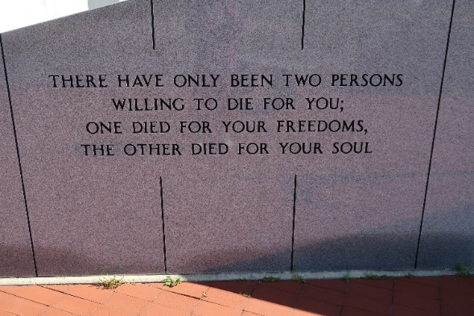

Verline Josephine Borne, a native and resident of Vacherie, passed away on Thursday, January 17, 2019 at the age of 91.
A visitation will be held from 8 a.m. until funeral time on Monday, Jan. 21, at Our Lady of Peace Catholic Church. Mass of Christian Burial will take place at 11 a.m. Interment will follow in the church cemetery, Our Lady of Peace Catholic Church Cemetery.
She is survived by her children, Judy (Michael) Clement, Wade (Julie) Borne, and Debbie (Teddy) Bourgeois; 5 grandchildren, Jonathan (Shelby) Clement, Matthew (Abbey) Borne, Renee (Drew) Biondo, Laura Borne, and Dana Bourgeois; and 1 great-granddaughter, Annie Biondo.
She is preceded in death by her husband, Fred Borne; sisters, Azema Folse, Elaine Schexnayder, and Cecilia Reulet; brothers, Pierre Helton Reulet, Herbert Reulet, Herman Reulet, and Charles Reulet; and parents, Charles and Elise Steib Reulet.
Verline enjoyed spending time with her family, especially around the dinner table. The family would like to thank everyone for their prayers and support during her brief illness.
Thibodaux Funeral Home is in charge of arrangements.
Houma Today & The Daily Comet, Terrebonne Parish, Louisiana
Jan. 18 to Jan. 19, 2019

