Raymond P. Boudreaux Jr.
September 8, 1951 – May 14, 2016

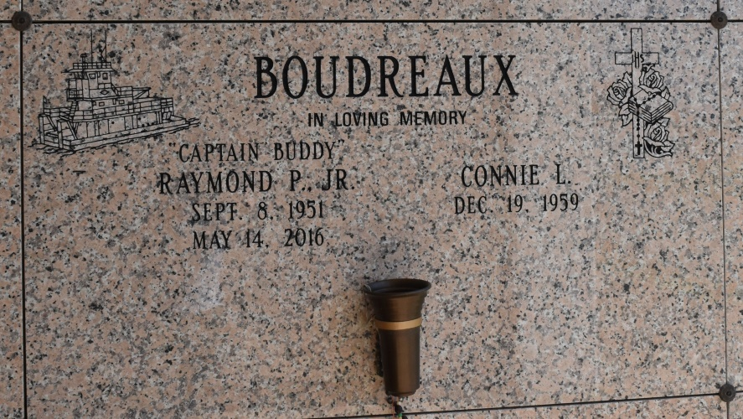

Raymond "Capt. Buddy" Boudreaux, 64, a resident of Vacherie, LA was called to eternal rest on May 14, 2016.
A visitation will be held in his honor on Monday, May 23, 2016 at Our Lady of Peace Catholic Church, Vacherie, LA from 1:00 PM until the Mass of Christian Burial at 3:00 PM. The burial will be at a later date in Our Lady of Peace Cemetery.
He is survived by his wife of 25 years, Connie Boudreaux; four sons, Raymond Peter Boudreaux, III (Michele), Randy Paul Boudreaux Sr. (Kimberly), Reginald Phillip Boudreaux, Sr. (Mandy), Bryan Patrick Noel, Jr.; two daughters, Ashley Elizabeth Noel, Krystle Ann Noel (Michael); five sisters, Judy Mericle (Gary), Kathey Dufrene (Nolan Jr.), LaVern Bruce, Lorraine O'Neal (Thomas), Robin Coleman (Roger Sr.); brother, Austin Boudreaux Sr.(Dawn); sister in law, Lorretta Ray; 28 grandchildren; 7 great-grandchildren; mother-in-law, Linda Lacour; 2 brother- in-laws; 1 sister-in-law; and numerous nieces and nephews.
He was preceded in death by his parents, Raymond and Etta Callahan Boudreaux Sr.; three brothers, Gale Ray, Michael Boudreaux, Sr., John Boudreaux; 2 grandchildren; father-in-law, Gerald Lacour Sr.; brother-in-law, Dewey Bruce Jr.
Thibodaux Funeral Home, Inc. is in charge of arrangements.

Houma Today, Terrebonne Parish, LA
May 19 to May 20, 2016.

