Althee Marie “Eve” Bourgeois
January 31, 1879 – July 3, 1960

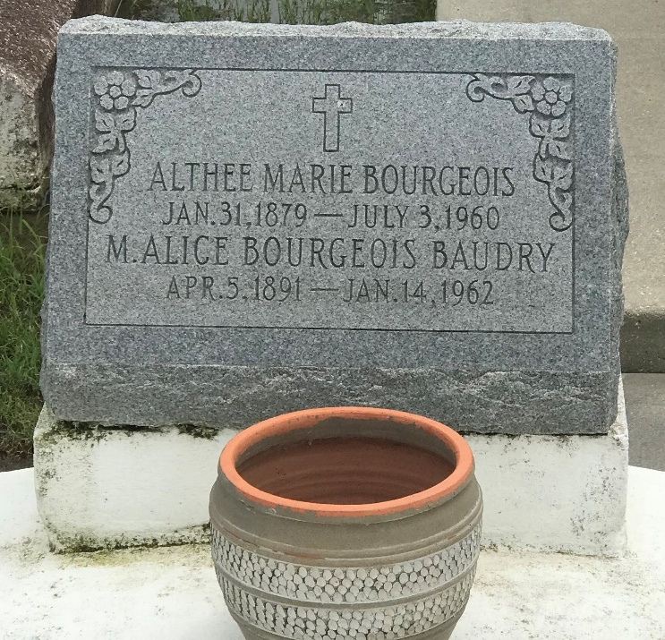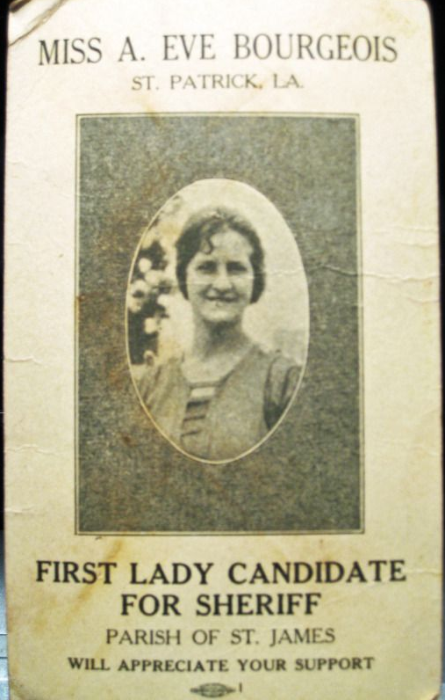
Photos by rrcar

BOURGEOIS – On Sunday, July 3, 1960, at 5 o’clock a.m. Althee Bourgeois, beloved sister of Mrs. Alice Baudry and Maurice J. Bourgeois of New Braunfels, Tex., daughter of the late Victor Bourgeois and Dar--- Weber, sister of the late Ferdinand, Lawrence and George Bourgeois, aged 81 years; a native of St. James parish and a resident of Laplace, La.

Funeral took place from the Alexander Funeral Home, Lutcher, La., on Monday, July 5, 1960, at 8:15 o’clock a.m. Requiem Mass at St. Joan of Arc Catholic church, Laplace, La., at 9 o’clock a.m.

Interment in Our Lady of Peace cemetery, Vacherie, La.
Unknown source

