Anna Lee (Becnel) Bourgeois
April 8, 1943 – July 16, 2023

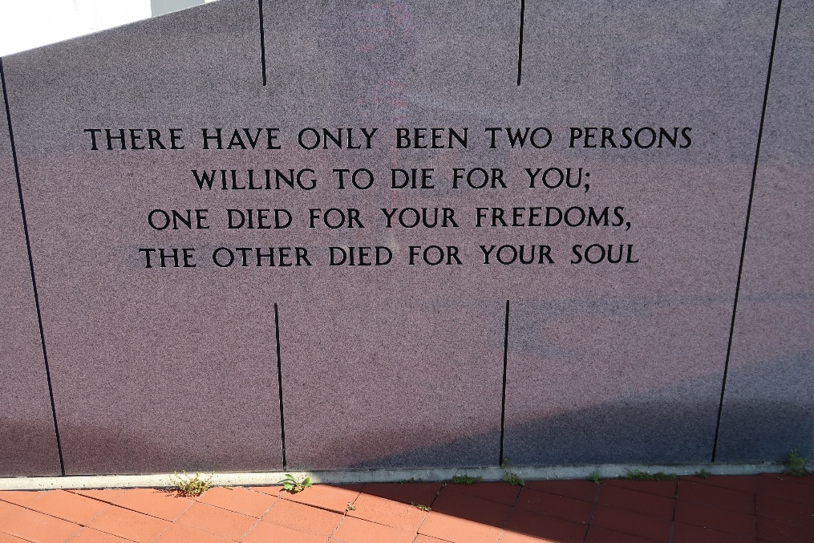

Anna Becnel Bourgeois passed away on Sunday, July 16, 2023, at the age of 80. She was a native of Vacherie, Louisiana, and long time resident of Metairie, Louisiana.
A visitation will be held in her honor on Saturday, July 22, 2023, at Our Lady of Peace Catholic Church in Vacherie, the church where she received all of her Sacraments, from 11:00am until the Mass of Christian Burial at 1:00pm. Interment will follow at Our Lady of Peace Catholic Cemetery, Vacherie, Louisiana.
She is survived by her beloved husband of 59 years, Donald C. Bourgeois, daughter, Jan B. Casey, son-in-law, Christopher Casey, and her 12 cherished grandchildren: Steven, Mary, Bernadette, Margaret, Victor, Madeleine, Joanna, James, Laura, Joseph, Virginia, and Solana Casey. She is also survived by her brother Leroy Becnel and family and friends.
She was preceded in death by her parents, Amelus and Leone Stein Becnel and her brothers, James and Louis Becnel.
She was a dedicated employee for the Archdiocese of New Orleans in food service at both St. Catherine of Siena School and Cabrini High School, before retiring after 30 years. She won the Archdiocesan Cafeteria Technician of the Year for Elementary Schools Award in 1999. She also volunteered tirelessly at St. Catherine of Siena as a room mother, room captain, and fair chairwoman during the time her daughter attended there. While working in the school's cafeteria, and at the after school care program, she continued volunteering and helping at the school. She is remembered fondly by everyone who knew her. Her greatest love was being a wife, mother, and Granny. Her devotion to her Faith and her family was always evident.

Thibodaux Funeral Home, Inc., Lafourche Parish, Louisiana

