Ellis Joseph Bourgeois
January 12, 1913 – November 15, 2008

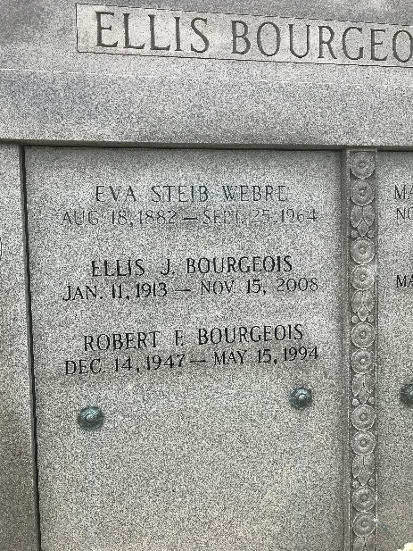
Photo by rrcar

Ellis Joseph Bourgeois, a father, a grandfather, and great grandfather died at 12:20 A.M. on Saturday, November 15, 2008, in Thibodaux, LA. He was 95 and resident and native of Vacherie, LA.
Visiting will be at Our Lady of Peace Catholic Church, Vacherie, on Tuesday, November 18, 2008 from 8 A.M. until Mass of Christian Burial at 11 A.M. Entombment will follow in Our Lady of Peace Cemetery.
He was Assessor of St. James Parish for twenty years. He was member of the LA Assessor's Association, Knights of Columbus Council #1514, Lions Club, St. James Boat Club, Council on Aging, Martin Luther King Scholarship Foundation, St. James Historical Society, Molaison Deer Hunting Club, and usher at St. Philip Catholic Church in Vacherie.
Survived by five daughters and sons-in-law, Kathleen and Edward Hymel, Destrehan, LA, Eva and Robert Dufresne, Gramercy, LA, Jeanne and Norman Adams, Vacherie, LA, Corinne and Alvin Dupepe, Donaldsonville, LA, and Susan and Randy Hotard, Vacherie, LA; four sons and daughters-in-law, Leo and Gaynell Bourgeois, Roland and Linda Bourgeois, Ronald and Julie Bourgeois, and Teddy and Debbie Bourgeois, all of Vacherie, LA; twenty-six grandchildren; forty-five great grandchildren.
Preceded in death by his wife, Lena Webre Bourgeois; parents, Edward J. Bourgeois, Sr. and Anne Sevin; two sons, Robert and Al Bourgeois; two grandsons, Leo Bourgeois, Jr. and Matthew Dupepe and one infant great-granddaughter, Alyssa Nickens; one sister, Ruth Danos; three brothers, Lee Bourgeois, Edward J. Bourgeois Jr., and Joe Bourgeois.
In lieu of flowers, Memorial donations made to the Building Funds of St. Philip and Our Lady of Peace Catholic Churches in Vacherie, LA.
Alexander Funeral Home of Lutcher in charge of arrangements.

Legacy Remembers
Nov. 16 to Nov. 17, 2008

