Emanuel Joseph Bourgeois
February 1, 1943 – November 12, 2024

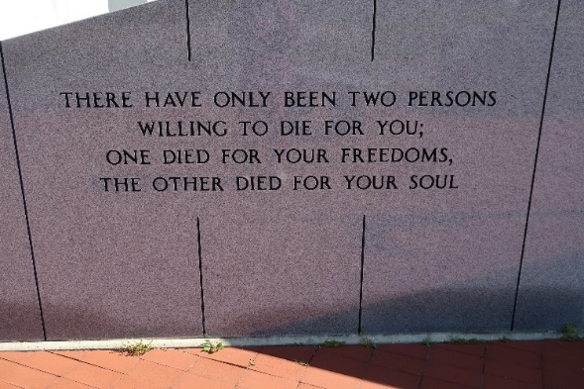

Emanuel J. Bourgeois, age 81, a lifelong resident of Vacherie, Louisiana peacefully passed away on Tuesday, November 12, 2024.
A visitation will be held in his honor on Saturday, November 16, 2024 at Our Lady of Peace Catholic Church, in Vacherie, Louisiana from 8:30 am until the Mass of Christian Burial at 10:30 am. The burial will follow in Our Lady of Peace Cemetery.
He is survived by his brother, Errol Bourgeois (Beryl); sister, Mary Ann Richardson; niece, Melissa Kernan (Corey); nephews, Errol Bourgeois Jr. and Corby Bourgeois (Michelle); sister in law, Veronica Bourgeois; cousin, Wade Borne; and numerous great nieces and nephews.
He was preceded in death by his parents, Joseph Bourgeois Sr. and Loretta Bourgeois; and brother, Joseph Bourgeois Jr.
Emanuel was a huge LSU and Saints football fan, he was always sure to watch the game. He absolutely loved his visits with his family and friends. He was loved by all and will be deeply missed.
The family would like to send our a heartfelt thanks to the Staff at Thibodaux Regional Health System, especially Dr. Michael Firstenberg for all of their love and care.

Landry's Funeral Home, Inc., Thibodaux, Louisiana

