Joseph Robert Bourgeois
October 10, 1916 – April 5, 1983

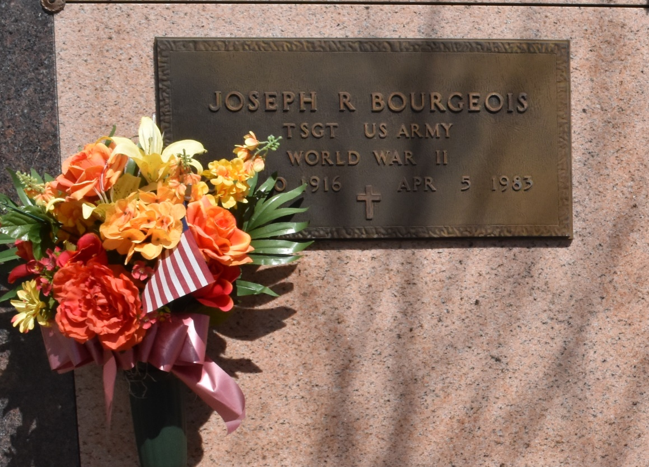

Religious services have been scheduled for 10 a.m. Saturday at Our Lady of Peace Catholic Church, Vacherie, for Joseph Robert Bourgeois, 66, a native of Vacherie and a resident of Redding, Calif. for 13 years, who died at 9:55 a.m. Tuesday in Redding, Calif.
Interment has been scheduled in the church cemetery. Visitation will be from 8-10 a.m. Saturday.
He was the husband of the late Faye Taylor Bourgeois; brother of Ellis Bourgeois, Edward Bourgeois, Mrs. J. Maurice (Ruth) Danos and the late Lee Bourgeois.
Arrangements by Falgout Funeral Home, Raceland.

Lafourche Comet, Lafourche Parish, La.
Apr 8, 1983

