Therese (Delatte) Bourgeois
December 28, 1922 - June 9, 2016

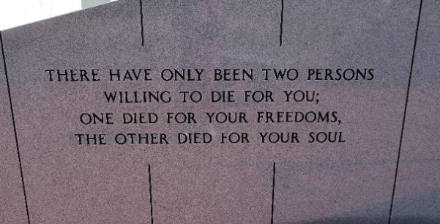

Therese Delatte Bourgeois, 93, passed away on Thursday, June 9, 2016. She was a native and resident of Vacherie, LA.
A visitation will be held on Saturday, June 11, 2016 at Our Lady of Peace Church in Vacherie, LA from 8:00 am until the Mass of Christian Burial at 10:30 am. Burial will follow at the church cemetery.
She is survived by her children, Eleanor Hymel and husband Nolan, Allen P. Bourgeois, Frank J. Bourgeois and wife Susan, Rose Marie Morvant and husband Eugene, Charles E. Bourgeois and wife Renee, Lee Bourgeois, Jr. and wife Donna, Curtis J. Bourgeois and wife Susan, and Mary Granier and husband Dwayne; son-in-law, Andy Branciere; 13 grandchildren; and 12 great-grandchildren.
She was preceded in death by her husband, Lee Bourgeois, Sr.; parents, Frank Delatte and Honorine Schexnayder Delatte; son, Norman M. Bourgeois; daughter, Marilyn Branciere; grandson, Shannon Morvant; brothers, Alvest, Clarence, William, John, Lionel, Jules, and Thomas Delatte; and sisters, Alcidie Leroux and Marie Delatte.
The family would like to give a special thanks to her caregivers, Gracie Dumas, Belinda Marse, Frances Dumas, and Adline Williams; as well as Thibodaux Regional Medical Center, Dr. Chester Boudreaux and staff, and Divinity Home Health for their love and care.
Thibodaux Funeral Home, Inc. has been entrusted with making the funeral arrangements.

The Advocate, Baton Rouge, Louisiana
Jun. 9 to Jun. 11, 2016

