Francois Joseph Brazan Jr.
September 7, 1940 – April 5, 2019

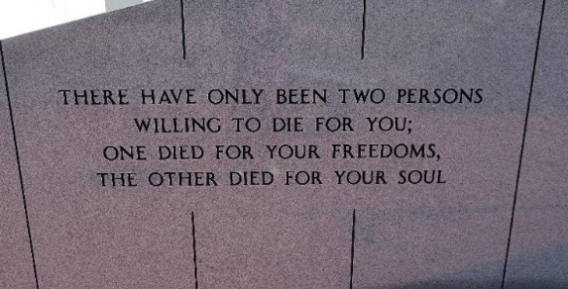

Francois "Frank" Brazan, 78, a native and resident of Vacherie, passed away on April 5, 2019.
A visitation will be held in his honor on Wednesday, April 10 at Our Lady of Peace Catholic Church in Vacherie from 8 a.m. until the Mass of Christian Burial at 11 a.m. The burial will follow in the church cemetery.
He is survived by his wife of 57 years, Gennel Thibodeaux Brazan; sons, Frank Brazan (Sandra), Shane Brazan (Debbie), and Jason Brazan (Terri); daughters, Pennie Kliebert (Wayne) and Carmel Bourg (Charles); brother, Raymond Brazan (Patricia); grandchildren, Joanie Ferrell (Brian), Jennifer Charlie (Casey),Trey Brazan (Shannon), Tylor Brazan, Leah Brazan, Lacie Gary (Jacob), Brooke Pitre (Matthew), Bryce Brazan, Brennen Brazan, and Braelyn Brazan, Chelsea Kliebert, Marcus Kliebert, Connor Kliebert, and Hannah Bourg; great-grandchildren, Cohen Ferrell, Annabelle Ferrell, J.D. Charlie, Reyna Gary, Hannah Gary, Emmett Pitre, and Liam Pitre; brother-in-law, Larry Gravois; and sister-in-law, Merline Millet.
He was preceded in death by parents, Francois Joseph Brazan Sr. and Lucille Ockmond Brazan Derocher; daughter, Kelly Sue Brazan; brother, Frederick "Fred" Brazan, and sister, Eloise Gravois.
Thibodaux Funeral Home, Inc. is in charge of arrangements.

Houma Today, Terrebonne Parish, Louisiana
Apr. 7 to Apr. 9, 2019

