Gaspard James Brazan
December 24, 1950 – December 14, 2012

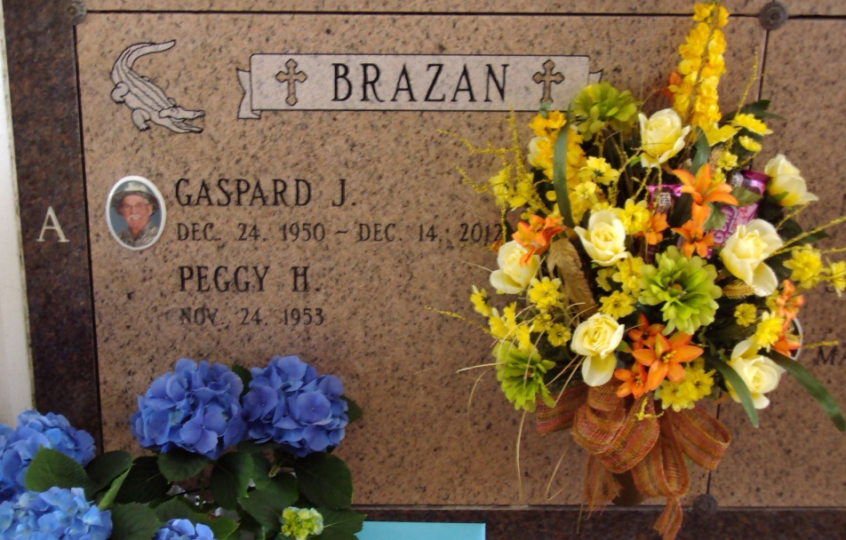
Photo by rrcar

Gaspard James Brazan, 61, was born on December 24, 1950 and passed away on Friday, December 14, 2012. He was a native and resident of Vacherie.
Visitation will be on Tuesday, December 18, from 8 a.m. until funeral time at 12 noon at Our Lady of Peace Catholic Church in Vacherie, with burial in the church cemetery.
He is survived by his wife, Peggy Hotard Brazan; daughter, Brookes Brazan Waguespack and husband, Craig; two grandchildren, Jonah and Wyatt Waguespack; sisters, Anne Peterson, Lydia Dufrene, Rose Becnel, Essie Brazan, Patricia Bellanger, and Cheryl Hubbell.
He was preceded in death by his parents, Olinie Lassere Brazan and Louis F. Brazan, Jr.; son, Ronnie James Brazan; and brother, Charles Brazan.
He was employed by Occidental Chemical in Convent. He was a member of the Knights of Columbus Council 11857, Vacherie; Deer Club, President; Nuisance Alligator Hunter for St. James Parish; and Eucharistic Minster.

Thibodaux Funeral Home Inc., Lafourche Parish, Louisiana
Dec. 14, 2012

