Louis Francois Brazan Jr.
February 17, 1903 – December 7, 1981

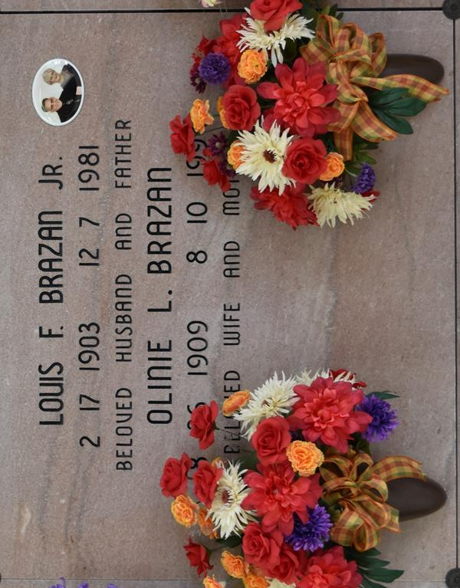

Louis Francois Brazan, Jr., on Monday December 7, 1981, at 11:48 o’clock AM. Husband of Oline Lassere Brazan; father of Anne Peterson and Cheryl Holmes, both of Baton Rouge, Louisiana; Lydia Dufrene of Chalmette, Louisiana, Rose Brazan Kliebert, Patricia Bellander and Gaspard Brazan, all of Vacherie, Louisiana. Also survived by 15 grandchildren and 12 great grandchildren. Age 78 years old.
Relatives and friends of the family are invited to attend the funeral. Services from Our Lady of Peace Parish hall, Vacherie, Louisiana, on Wednesday, December 9, 1981 at 10 o’clock AM followed by a mass of Christian Burial at Our Lady of Peace Catholic Church, Vacherie, Louisiana. Interment Our Lady of Peace cemetery. Visitation at Our Lady of Peace Parish Hall on Tuesday, 5 o’clock PM to 11 o’clock PM, Wednesday 11 o’clock AM until funeral time. Arrangements by Landry Funeral Home.

Times-Picayune, New Orleans, Louisiana
Tuesday, Dec 08, 1981, p. 21

