Louis Francois Brazan Sr.
October 13, 1867 – May 18, 1940

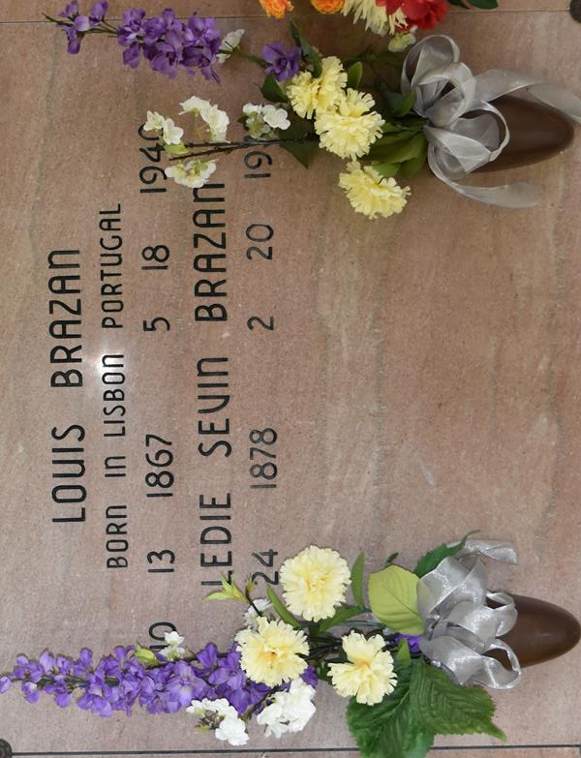

BRAZAN – Of Vacherie, La., on Saturday, May 18, 1940, Louis Brazan, Sr., husband by second marriage of Lydie Sevin, father of Mrs. Ozanne Gravais, Louis, Jr., Mrs. Amidee Schexnayder, Francais, Yolande, and Harry Brazan and the late Richard Brazan; a native of Lisbon Portugal and a resident of Vacherie, La. for many years.

Relatives and friends of the family are respectfully invited to attend the funeral which will take place Sunday afternoon, May 19, 1940. Interment Vacherie cemetery.

Times-Picayune, New Orleans, Louisiana
Sunday, May 19, 1940, p. 6

