Louis P. Brazan Sr.
March 12, 1923 – June 4, 2013

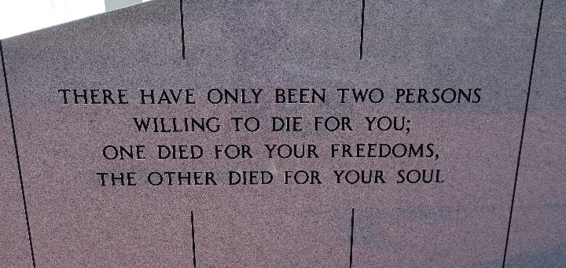

Born in Boyce, La. on March 12, 1923. A native of Vacherie, La. and long time resident of Laplace, La. died at 3:58 p.m. on Tuesday, June 4, 2013. Age 90.
Visitation will be Saturday, June 8, 2013 from 8:30AM until funeral time at Our Lady of Peace Catholic Church in Vacherie, LA. A Mass of Christian burial will be at 11AM at the church, with burial in the church cemetery.
He is survived by one son, Louis P. Brazan, Jr., daughter-in-law Wanda Usry Brazan; two grandchildren Tara Brazan Sarver (Chris) and Louis P. Brazan, III (Ashley); one great grandchild Hannah Elizabeth Sarver. Also survived by his twin brother Joseph Webre Brazan and sister Ollie Brazan Morlier.
Preceded in death by his wife of 54 years, Cecile Schexnayder Brazan, parents Richard and Elizabeth Webre Brazan; one daughter Susan Elizabeth Brazan, two brothers; Ray and Richard Brazan, two sisters, Lois Brazan Durocher and Louella Brazan Pavlovich.
He was a loving husband, father, grandfather and great-grandfather. He will be dearly missed by all who knew him.
The family would like to give a special thanks to the Doctor's and staff at Southeast Louisiana War Veterans Home as well as the family and friends that visited him in his time of need.
Thibodaux Funeral Home is in charge of arrangements.

Times-Picayune, New Orleans, Louisiana
June 6-7, 2013

