Mercedes (Billon) Brazan
September 29, 1915 – May 2, 2004

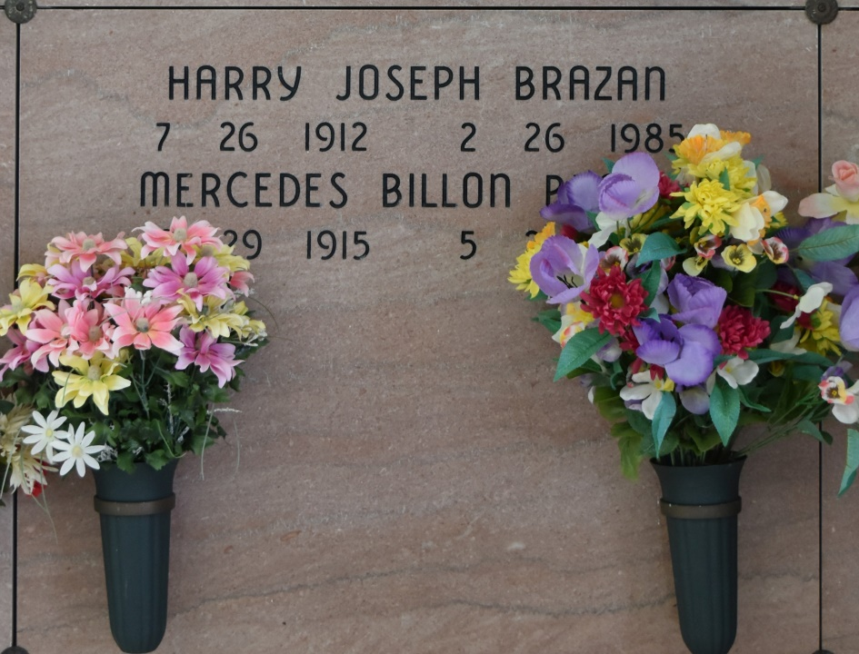

A school teacher with St. James and Ascension Parish school boards and a resident of Vacherie, she died at 12:10 a.m. Sunday, May 2, 2004, in Baton Rouge. She was 88 and a native of St. James.
Visiting at Our Lady of Peace Catholic Church, Vacherie, from 8 a.m. until Mass of Christian Burial at 11 a.m. Monday, May 3, 2004, conducted by the Rev. Michael Micelli. Entombment in church mausoleum.
Survived by a daughter and son-in-law, Paulette and William Kenneth Onley, Gonzales; two sons and daughters-in-law, Gordon and Janni Brazan, Schriever, and Craig and Catherine Brazan, Lafayette; eight grandchildren and a great-grandchild.
Preceded in death by her husband, Harry J. Brazan; daughter, Rosary Ann Brazan; a sister, Camille Billon; a brother, Paul Michael Billon Jr.; and parents, Paul Sr. and Aline Hymel Billon.
Ourso Funeral Home, Donaldsonville, in charge of arrangements.

The Advocate, Baton Rouge, LA
May 3, 2004

