Olinie (Lasserre) Brazan
August 26 1909 – August 10, 1994

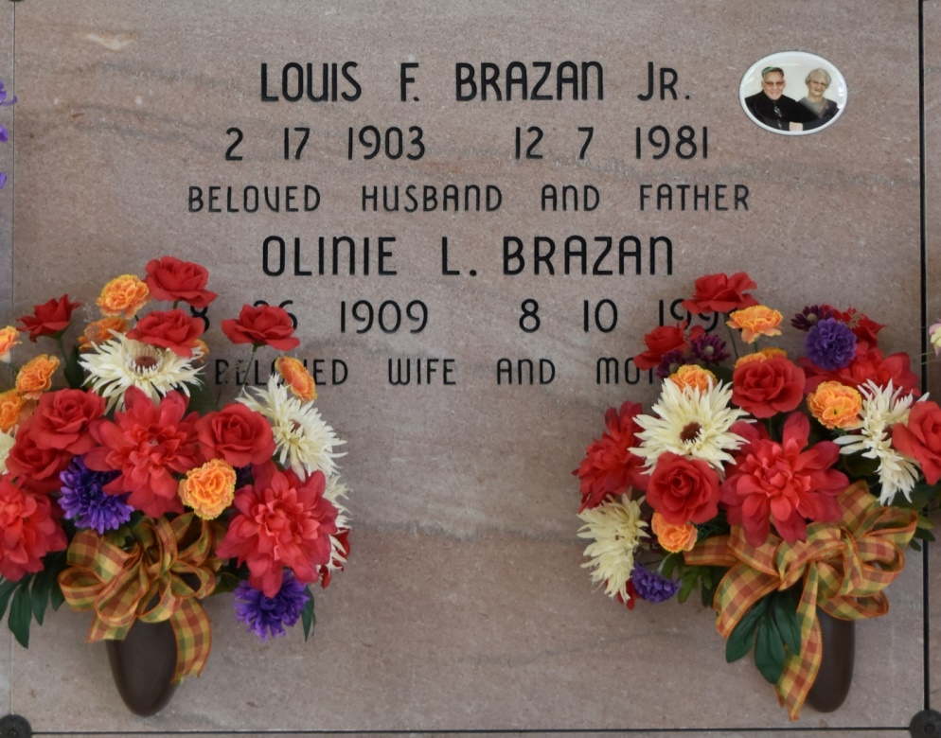

A Mass of Christian burial will be celebrated at 10 a.m. Saturday at Our Lady of Peace Catholic Church in Vacherie for Olinie L. Brazan, 84, a native and resident of Vacherie who died at 2:40 p.m. Wednesday, Aug. 10, 1994. Visitation will be 6 to 10 p.m. Friday and 8 a.m. until funeral time Saturday at the church. Burial will be in the church cemetery.
She was the mother of Charles, Essie and Gaspard Brazan, Ann Peterson, Lydia Dufrene, Rose Becnel, Patricial Bellanger and Cheryl Holmes; sister of Norman and Johnny Lasserre Jr., Isabelle Simon, Doris Joblanski and Lucette Hanlin. She is also survived by 15 grandchildren, 21 great-grandchildren and seven great-great grandchildren.
She was preceded in death by her husband, Louis Brazan Jr.; parents, John and Celina Brock Lasserre; and six brothers, O’Neil, Frank, Numa, Lincoln, Gaspard and Malcolm Lasserre.
Thibodaux Funeral Home is in charge of arrangements.

Unknown source

