Richard J. Brazan Sr.
August 2, 1918 – July 19, 2002

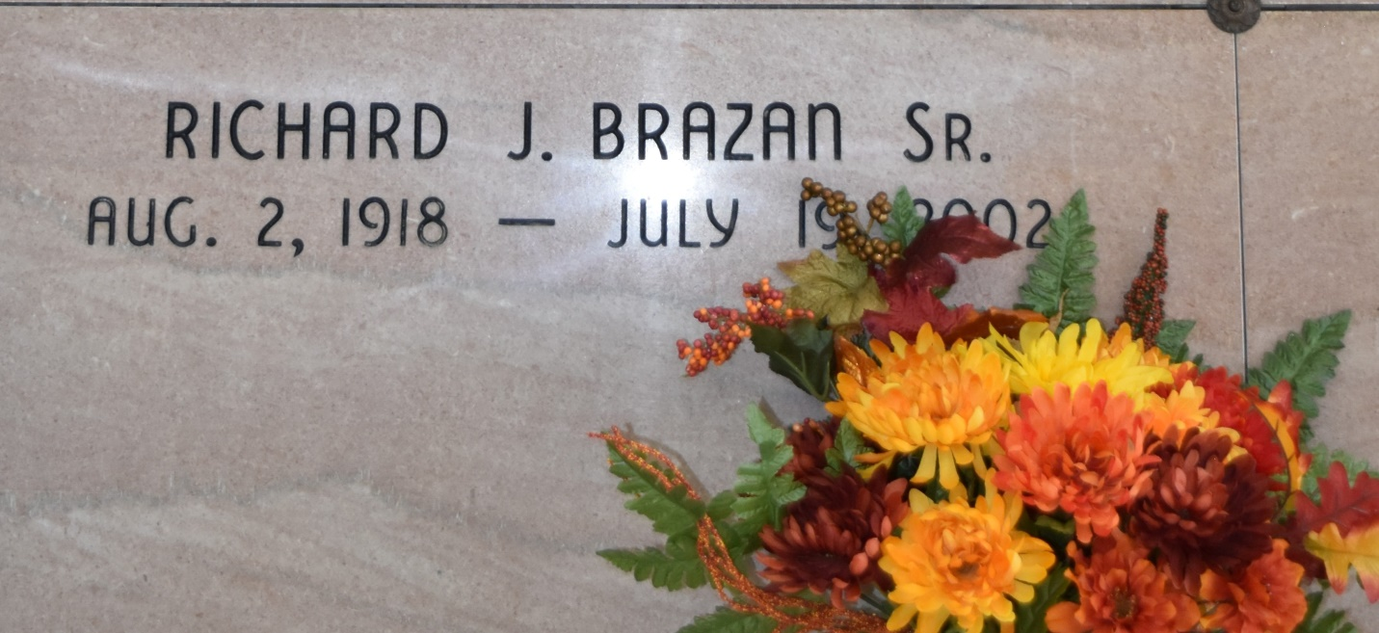

SOUTH VACHERIE – Richard J. Brazan Sr., 83, a native of Addis and resident of Vacherie, died July 19. He was the father of Donna Gauthreaux and Susan, Richard Jr., Paul, Patrick, James and Thomas Brazan.
He was the son of the late Richard and Elizabeth Webre Brazan and brother of Lois Durocher, Ollie Morlier, Louis and Joseph Brazan and the late Louella Pavlovich and Ray Brazan. He is also survived by 10 grandchildren and one great-grandchild.
Services were July 22 at Our Lady of Peace Catholic Church, South Vacherie, with interment at the church cemetery.

L’Observateur, LaPlace, LA
July 24, 2002

