Elda (Tregre) Breaux
November 6, 1918 – January 2, 2012

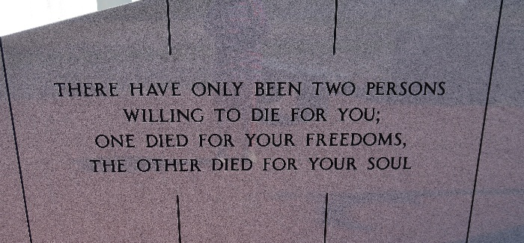

Elda Tregre Bye Breaux, 93, beloved mother, grandmother, great-grandmother and great-great-grandmother, passed away in Vacherie on Monday, Jan. 2, 2012.
Visitation will be from 9 a.m. to funeral time Thursday at Thibodaux Funeral Home Chapel, 104, St. Patrick Hwy. in Thibodaux. Religious services will be held at 11 a.m. Thursday at the chapel, with burial at Our Lady of Peace Cemetery in Vacherie.
She is survived by her son, Johny Bye and wife, Darlene Nesonovish; three daughters, Helen and husband, Elic Gravois, Molly Kippers and Elda Bye; three brothers, Alfred and wife, Fanny, Lee and wife, Nell, and Robert and wife, Pattie; three sisters, Earline Kraemer, Louise Hotard, and Sally Dufrense and husband, L.J.; and sisters-in-law, Melodie and Mildred.
She was preceded in death by her husband, Leonce Bye; second husband, Clannis Breaux; daughter, Doris Clay; parents, Beronie and Vinia Tregre; four brothers, Guy, Benoit and wife, Theolaine, Herbert, and Edwin and wife, Izama; sister, Lucy; sons-in-law, Eddie Kippers and Paul Lapeyrouse; and brothers-in-law, Franklin Kraemer and Theodore Hotard.
The first of 12 children, Elda was born in Vacherie on Nov. 6, 1918 to Beronie and Vinia Folse Tregre. She had four daughters and one son.
The family would like to thank St. Joseph Hospice for their loving care.
In lieu of flowers, donations may be made to St. Joseph Hospice, 103 Ridgefield Rd., Thibodaux, LA 70301.
Thibodaux Funeral Home is in charge of arrangements.

Houma Today, Terrebonne Parish, Louisiana
January 4-5, 2012

