Adeline (Poirrier) Bright - Merkel
June 11, 1928 – August 10, 2007

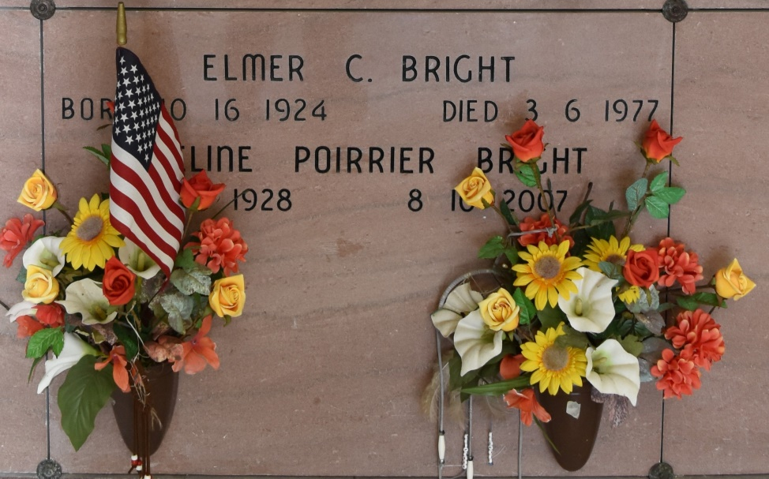

Adeline Poirrier Bright Merkel on Friday, August 10, 2007. Beloved wife of August P. Merkel and the late Elmer C. Bright from a first marriage. Mother of Kitty Dufrene (Gary), Brenda Keller (Roger) and the late Mary ""Beth'' Blount. Daughter of the late jean Willis Poirrier and Frieda Falgoust Poirrier. Sister of Phyllis Bodin (Rueben), Whitney, Doris and the late Willis ""Junior'' Poirrier. Grandmother of Dana Talkington (Bobby), Paul Olano III, Joshua Blount, Chad (Kelly) and Troy Keller and Tasha Sheets. Great-grandmother of Brandt Talkington, Paul Olano IV, Dominick Sheets and Tyler Keller.
Survived by a host of nieces and nephews. Age 79 years. A native of Vacherie, LA and a resident of Gretna, LA. Special thanks to Serenity Hospice Services.
Relatives and friends of the family are invited to attend the Visitation at Mothe Funeral Home, 2100 Westbank Expressway, Harvey, LA on Monday, August 13, 2007 from 9:00 a.m. until 12:30 p.m. Followed by a Funeral Mass at Our Lady of Peace Catholic Church, Vacherie, LA at 2:00 p.m. Interment Our Lady of Peace Catholic Church Mausoleum, Vacherie, LA.

Times-Picayune, New Orleans, LA
Aug. 12 to Aug. 13, 2007

