Nola (Oubre) Brignac
April 21, 1929 – November 2, 2020

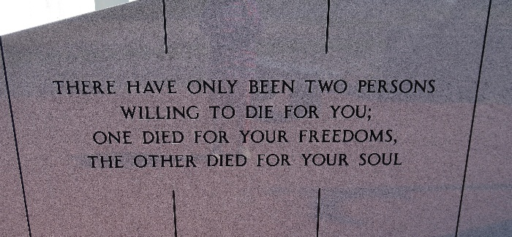

Nola Oubre Brignac, a native and resident of Vacherie, LA passed away on Monday, November 2, 2020 at the age of 91.
Visitation will be held on Thursday, November 5, 2020 at Thibodaux Funeral Home from 8:30 am until 10:00 am. A Mass of Christian Burial will be held at Our Lady of Peace Catholic Church at 11:00 am. Interment will follow on the grounds of Our Lady of Peace Mausoleum, where she will be reunited with her beloved husband.
She is survived by her three children, Sharon Rodrigue and husband Peter, Jay Brignac and wife Cindy, Carol Oncale and companion Terry Usea; four grandchildren, Dustin Rodrigue and wife Heather, Dr. Cody Brignac and wife Dr. Aubrey Brignac, Katie Brignac, and Kirsten Oncale and companion Buddy Johnson; four great-grandchildren, Zoe and Zachary Rodrigue, Drea and Raelynn Johnson; two sisters, May Granier and Maggie Gravois; and numerous nieces and nephews.
She was preceded in death by her beloved husband, Roderick Brignac; her parents, Theobert and Athanasie Oubre; and siblings, Eddie Oubre, Sr., Edwin Oubre, Cecile Acosta, and Eda Webre.
The family would like to extend their gratitude to the staff at St. Joseph Hospice, and her sitters, Deborah, Grace, and Martha for their care and compassion during this time.
Thibodaux Funeral Home, Lafourche Parish, Louisiana

