Roderick Paul Brignac
October 14, 1926 – August 26, 2018

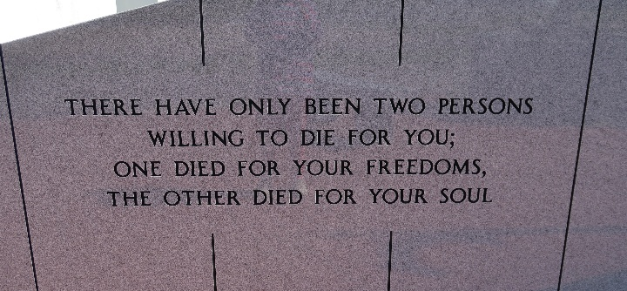

Roderick Paul Brignac, 91, a native of Convent and resident of Vacherie passed away Sunday, Aug. 26, 2018.
A visitation will be held in his honor from 9 a.m. until the Mass of Christian Burial at 11 a.m. Wednesday, Aug. 29 at Our Lady of Peace Catholic Church in Vacherie. The burial will follow in Our Lady of Peace Cemetery in Vacherie.
He is survived by his loving wife, Nola Oubre Brignac; three children, Sharon Rodrigue and husband, Peter, Jay Brignac and wife, Cindy, and Carol Oncale and companion, Terry Usea; four grandchildren, Dustin Rodrigue, Dr. Cody Brignac, Katie Brignac and Kirsten Oncale; four great-grandchildren; one brother, Roy F. Brignac; and two sisters, Pearl Hymel and Dorothy Louvierre.
He was preceded in death by his father, Gaston P. Brignac; mother, Lucrece St. Pierre Brignac; and three brothers, Patrick Brignac Sr., Bruce Brignac Sr. and Percy Brignac.
Mr. Roderick retired from the U.S. Postal Service at the age of 62 after working there for about 25 years. He served in the Army in World War II and later became a loyal member of the Vacherie VFW. He was also a dedicated parishioner of Our Lady of Peace in Vacherie for many years.
In lieu of flowers, donations can be made to the Southeast Louisiana Veterans Home Activity Fund, 4080 West Airline Highway, Reserve, LA 70084 or by calling 985-479-4080.
Thibodaux Funeral Home Inc. is in charge of arrangements.

Houma Today, Terrebonne Parish, Louisiana
August 28-29, 2018

