Larry Thomas Brignac
May 26, 1944 – April 7, 2011

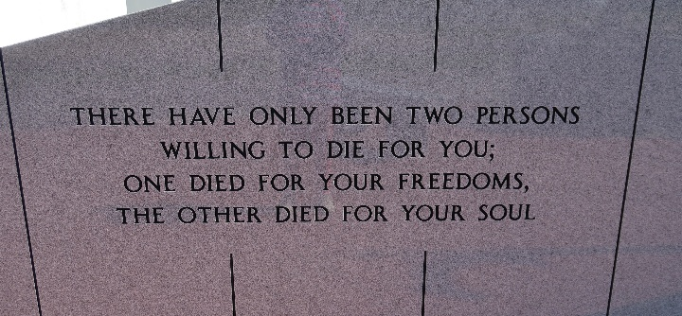

A resident of Pleasure Bend, he died Thursday morning, April 7, 2011. He was 66, born May 26, 1944, a native of Choupic.
Visitation at the Landry's Funeral Home chapel, Thibodaux, Wednesday, April 13, from 5 p.m. to 8 p.m. Visitation at Our Lady of Peace Catholic Church, Vacherie, Thursday from 7 a.m. until religious service at 10 a.m. Interment in Our Lady of Peace Cemetery.
He is survived by his former spouse, Jeanette Duhé Brock; son, Andre Brock and wife Tracey, of Jackson; daughter, Danielle Mensman and husband Chris, of Baton Rouge; three brothers, Gerald Brock and wife Kathy, of Delaware; Curtis Brock and wife Susan, of Texas; and Louis Brock and wife Melissa, of Virginia; four sisters, Roberta Verdun and husband Oscar, of Thibodaux; Marie Stella Rome and husband Johnny, of Chackbay; Della Brock, of Thibodaux; and Maria Riche and husband Mark, of Chackbay; sister-in-law, Susan B. Brock, of Virginia; four grandchildren, Estelle, Joseph and Henry Mensman and Benjamin Brock; 21 nieces and nephews and 30 great-nieces and great-nephews.
Preceded in death by his parents, Evariste Brock and Elsie Chiasson Brock; and two brothers, Charles Brock and Philip Rodney Brock.
He was always a true Cajun gentleman, avid outdoorsman, with intelligence and common sense. He had a generous heart and gave his all to his family and community. He was loyal to Jesus, a jokester and the heart and soul of his entire family. He always had the best hugs, good advice, a French expression and beautiful smile. He served as an LSU AgCenter county agent, taught agriculture internationally and served honorably in the Army. He will be missed by all whose lives he touched.
Thanks go out to the St. James and St. John the Baptist Parish Sheriff's Offices, Louisiana Department of Wildlife and Fisheries and U.S. Coast Guard, Port of South Louisiana, St. Tammany Volunteer Fire Protection and all who helped with the search.
In lieu of flowers, donations can be made to 4-H Memorial Scholarship Fund established in his name. Please send checks to LSU 4-H Foundation, 3233 S. Sherwood Forest Blvd., Suite 207, Baton Rouge, LA 70816.
Arrangements by Landry's Funeral Home, Thibodaux.
The Advocate, Baton Rouge, Louisiana
April 13, 2011

