Jasper Joseph Broden
January 15, 2016 – July 28, 2016

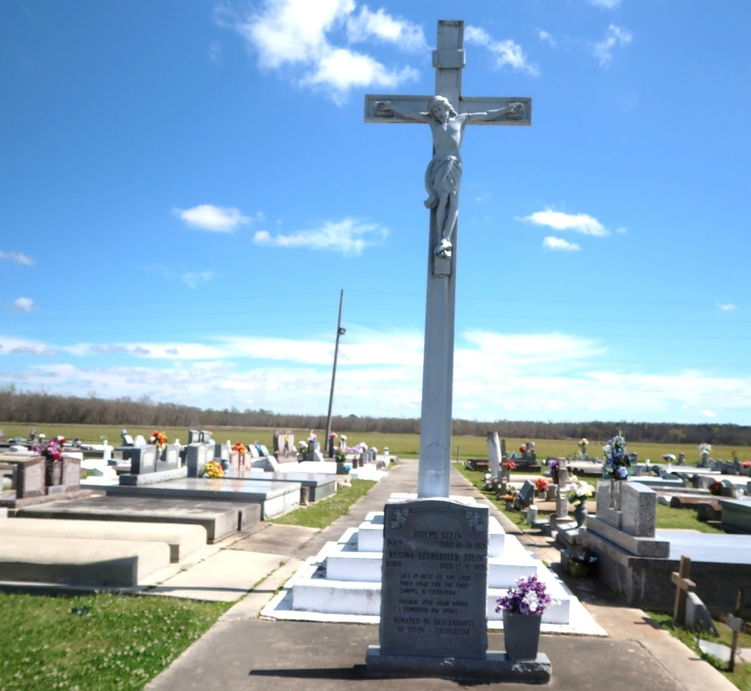

Baby Jasper Joseph Broden, “Gods little Angel’ went home on July 28, 2016, after only 6 months on the earth. In such a short time he touched the hearts of everyone that crossed his path. Especially those of his parents, Melinda Granier and Kalem Broden. Grandparents Andrew and Charlotte Granier, and Warren and Angela Broden. Not to mention his great-grandparents, uncles, aunts, nephews, and cousins.
Baby Jasper’s funeral service will be held on Wednesday, August 3, 2016, at Our lady of Peace Catholic Church, 13281 LA-644, Vacherie LA 70090, at 11:00 a.m. Immediate family will view from 9:00 a.m. until 9:30 a.m. followed by the general public viewing at 9:30 a.m. until time of service. Father Matthew McCaughey and Rev. Lionel Nelson, will officiate jointly. Baby Jasper’s final resting place will be in the church cemetery. Funeral entrusted to The Baloney Funeral Home, LLC, 1905 West Airline Highway, Laplace, LA, 985-224-8460.

Funeral card provided by Melinda Broden

