Velma (Dumas) Calloway
April 14, 1926 – June 17, 2013

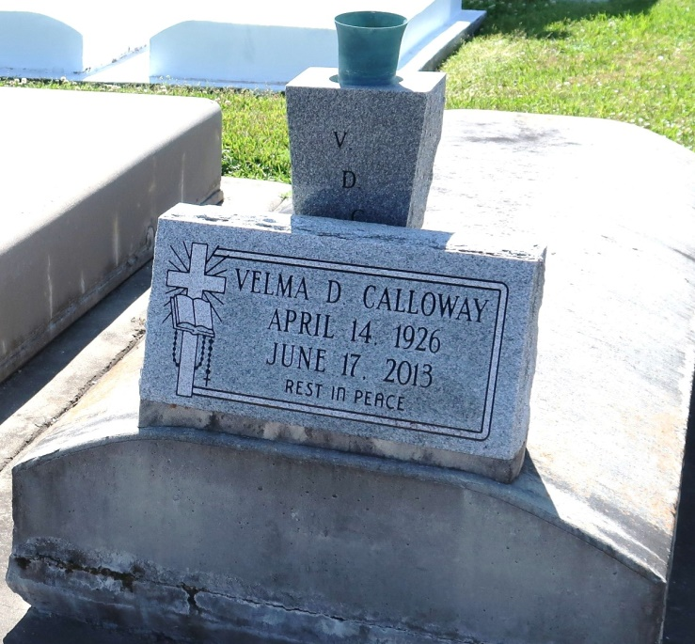

A native and resident of Vacherie. She died at Thibodaux Health Care Center in Thibodaux at 6:50 p.m. on Monday, June 17, 2013. She was 87. Visiting at Our Lady of Peace Catholic Church, Vacherie, on Tuesday, June 25, 2013 from 9:30 a.m. until Mass of Christian Burial at 11 a.m. conducted by the Rev. Michael Micelli. Interment in church cemetery. Survived by two sisters, Marie Helen Jeffery and Lois Batiste and husband August, numerous nieces, nephews, cousins, other relatives and friends. Preceded in death by her husband, Freddie Calloway; parents, Elphege Dumas and Eva Louis Dumas; six sisters, Cecillia D. Esteen, Mildred Dumas, Eva D. James, Essie D. Thornton, Priscilla D. Gros and Maude D. Lemieux; and four brothers, Eddie, Claude, Ralph and Bernard Dumas, Sr. Brazier-Watson Funeral Home in charge of arrangements.
Advocate, The (Baton Rouge, LA)
Friday, June 21, 2013
Contributed by Jane Edson

