Denise (Brock) Chapoton
September 16, 1916 – January 10, 2008

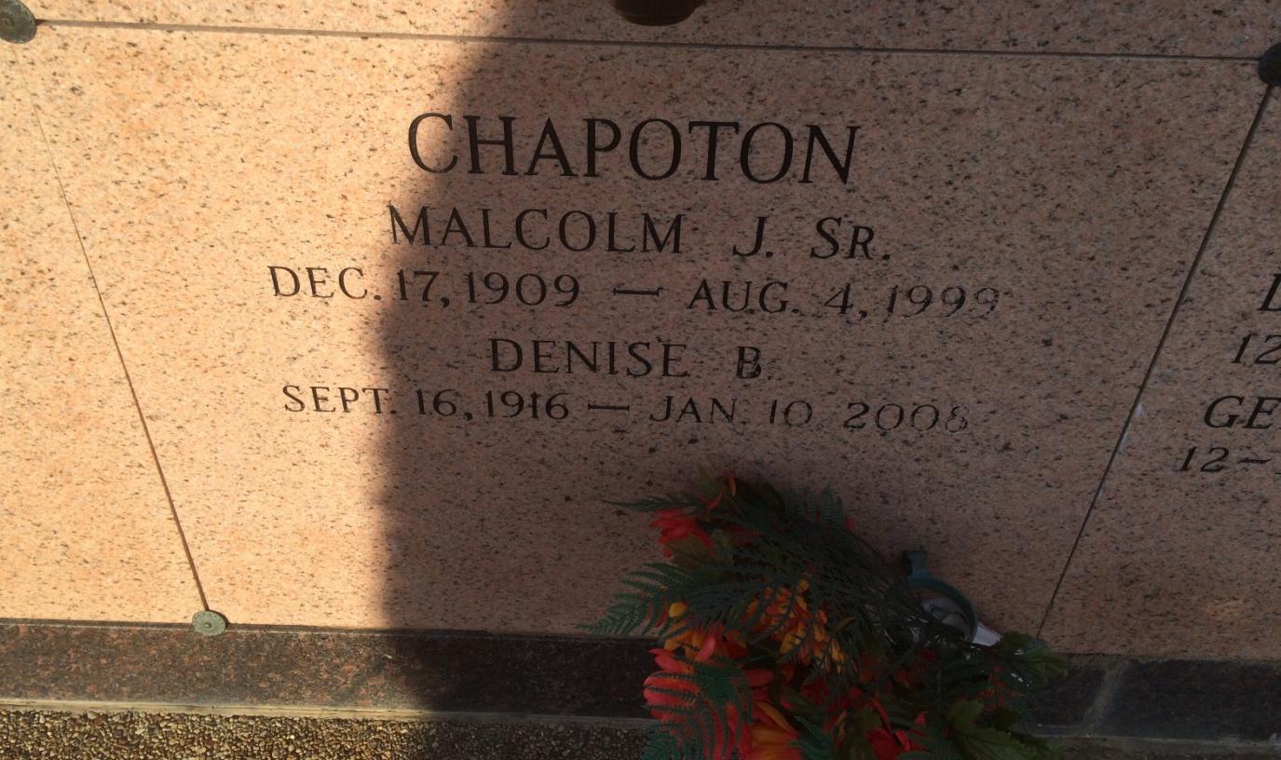
Photo by Kerry Keller

A homemaker and a resident of Lutcher, she died at 3:10 a.m. Thursday, Jan. 10, 2008, in Lutcher. She was 91 and a native of Vacherie. Visiting at St. Joseph Catholic Church, Paulina, on Saturday, Jan. 12, from 8:30 a.m. until Mass of Christian Burial at 10:30 a.m. Entombment in Our Lady of Peace Mausoleum, Vacherie.
She is survived by her children, Malcolm Jr., and Patricia Duhé and husband Clark, all of Lutcher, and Conrad and wife Cindy, of Wakefield; grandchildren, Bruce Duhé and wife Amy, Kevin Duhé and wife Ronette, Crystal Gravois and husband Chuck, Kenneth Duhé and wife Laura, Nadine Zvorsky and husband Vincent, Stacy Ritter, and Patti Gravois and husband Buddy; great-grandchildren, Abby, Samantha, Taylor, Sloane, Remi, Grace, Adam and Emma Duhé, Erin Mudge and husband Chris, Renee, Alison, Charles, Matthew, Jennifer and Paige Gravois, Tatyana and Steven Zvorsky and Cody Ritter; and a sister, Edian Landry.
She was preceded in death by her husband, Malcolm Chapoton Sr.; parents, Charles and Edna Hebert Brock; sisters, Edesse Bourg and Adles Benoit; brothers, Evariste, Louis, Charles and William Brock; two baby grandsons; and daughter-in-law, Marjorie Becnel Chapoton.
Arrangements by Alexander Funeral Home, Lutcher.
Published in The Advocate (Baton Rouge, LA) from January 11 to January 12, 2008
Contributed by Karen Klemm Pinckard

