Chad A. Clark, Sr.
March 6, 1974 - July 19, 2025

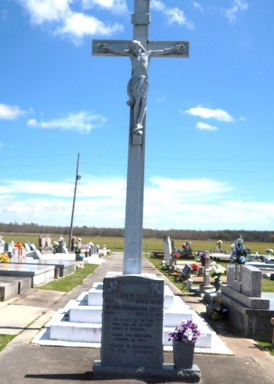

Chad Anthony Clark, Sr., affectionately known as Big "C" to some and a "Humble Giant" to others, and to his wife Jessica as "Honey Bun", was born on March 6, 1974, to the union of Euris Miller Clark and the late Linda Steib Clark at St. Joseph Hospital in Thibodaux, LA. On Saturday, July 19, 2025, he departed his earthly life at his home and entered eternal rest at the age of 51.
Chad was baptized at Our Lady of Peace Catholic Church, where he served as an alter boy as a youth. Chad was a 1992 graduate of St. James High School. He played basketball and baseball. After high school, he joined the United States Air Force, where he served his country for 4 years. He then continued his education at ITI in Baton Rouge, LA, earning his Associate’s degree in Computer Technology.
On July 8, 2004, Chad was united in holy matrimony to the love of his life, Jessica Aubert Clark. Their union was blessed with 2 loving sons, Chad Clark, Jr. and Dylan Aubert. Chad was an amazing, hard working man. He worked on alarm systems for a few years until his employment at Shell Chemical in Geismar, LA. He worked there as an Operator for 20 years, and in 2021 he opted for early retirement to continue managing his own businesses, Clark Unlimited, LLC and Property Services which he owned for over 18 years. He was also the owner of CJ Clark Properties, LLC.
Chad took care of his family in every way possible. He enjoyed working alongside his 2 sons. They laughed, worked hard, and enjoyed visiting various restaurants for their lunch breaks. Chad took pride in teaching his sons the business. He was very passionate and particular about how the work should be done. Every yard had to be perfect, and if it wasn’t done to his standards, he would let it be known. He strived to make every customer feel as though they were his only customer.
Chad really enjoyed spending time with his wife, his boys, and his grandchildren who had him wrapped around their fingers. Chad was a big time jokester and would always crack jokes at home. He enjoyed barbecuing, riding his four wheeler with Chad Jr., watching the Saints play, and talking with his buddies. He lived a simple life and it didn’t take much to satisfy him. His favorite sayings were “we are gonna cross that bridge when we get there” and “hang around me long enough and imma learn you something”. He had a very sarcastic personality, but he always made sure that everyone else was good before himself.
Chad leaves to cherish his precious memories his beloved and devoted wife of 21 years, Jessica Aubert Clark; children, Chad Clark, Jr. and Dylan Aubert( Jomekia Woods); grandchildren, Jace Aubert and Joleigh Augillard; parents, Euris (Bonus mom, Vera) Clark; brother, Dane Clark; bonus brother, Terrence (Christine) Evans; bonus sister, Tresa Evans; father-in-law, Jerome (Bonus mother-in-law, Migon) Aubert, Sr.; 3 brothers-in-law, Jerome Aubert, Jr., Justin (Amanda) Aubert, and Carvente (Seritha) Poche; bonus brother-in-law, Tevin Duplush (Jasmine); bonus sister-in-law, Alicia Duplush; aunts and uncles, Sylvia (Milton) Vinnett, Bishop James Terry Steib, Aldrick J. (Rhonda) Steib, Kenneth P. (Joycelyn) Steib, James, Mallory, Jerry (Vickie), and Catherine Clark, Sharleane (Brian) Stewart, Ann Willliams, Beverly (Jacques) Hayes, and Debra Washington, Perry Clark. Godparents, Catherine Clark and Kenneth Steib; Godchildren, Kade Steib, Jaira Steib and Jaxzy Laurent; a devoted cousin, Deshane Jones Birdis; a devoted friend, Errick Harper; and a host of nieces, nephews, other relatives and friends. Chad was preceded in death by his mother, Linda Steib Clark; maternal grandparents, Rosemond and Vivian J. Steib; paternal grandparents, Miller and Celeste Favorite Clark; mother-in-law, Debra Jones Aubert; brother-in-law, Jason Adam Aubert, and a host of other relatives. Chad was also reunited with his 2 best friends to complete their trio, Taj Laurent and Jai Steib.
A public visitation will be held on Friday, August 1, 2025, at Treasures of Life Funeral Services, 315 East Airline Hwy, Gramercy, LA 70052 from 5PM-7PM. A Mass of Christian burial will be held on Saturday, August 2, 2025, at Our Lady of Peace Catholic Church, 13281 LA-644, Vacherie, LA 70090. Visitation beginning at 8AM. Mass at 10:30AM. Interment to follow at Our Lady of Peace Catholic Church cemetery.

Treasures of Life Funeral Services, Gramercy, Louisiana
July 29, 2025

