Elsie (Narcisse) Clayton

August 15, 1926 – April 6, 2014

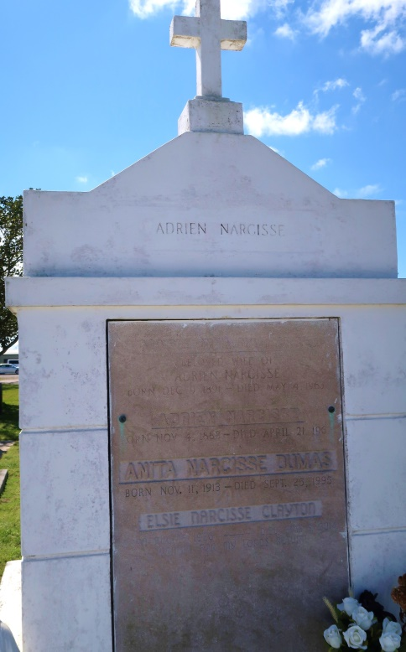 

Elsie Narcisse Clayton at the age of 87 yrs. departed this earthly life and entered into eternal rest on Thursday, April 3, 2014, at Ochsner Medical Center of Kenner, LA.

Daughter of the late Adrien and Marie Narcisse. Wife of the late Herman Clayton Sr. Beloved mother of Pastor Herman (Monica) Clayton Jr., Beverly (Ronald) Frank, Kenneth (Iris) Clayton, and Keresher Clayton. She was the beloved grandmother of 11 grandchildren, 22 great-grandchildren, and 2 great-great-grandchildren. And a host of nieces, nephews, other relatives, and friends. A native and resident of Lutcher, LA.

Relatives and friends of the family, also priest, and parishioners of Our Lady of Grace Catholic Church, employees of St. James Parish School Board, and all neighboring churches are invited to attend the Mass of Christian Burial on Friday, April 11, 2014, at 10:00 a.m. at Our Lady of Grace Catholic Church, 772 Hwy 44, Reserve, LA. Rev. Christopher C. Armadi, SSJ Celebrant. Viewing of the body will be on Thursday night from 5:00 p.m. to 7:00 p.m. at Bardell's Mortuary, 3856 Hwy 44, Mt. Airy, LA, and on Friday, April 11, 2014 from 8:00 a.m. to 10:00 a.m. prior to funeral service. Interment in Our Lady of Peace Cemetery of Vacherie, LA. Bardell's Mortuary of Mt. Airy, LA in charge. Information: 985-535-6837

Times-Picayune, New Orleans, LA

Apr. 8 to Apr. 9, 2014