Brennan John Clement
July 10, 1995 – July 15, 2018

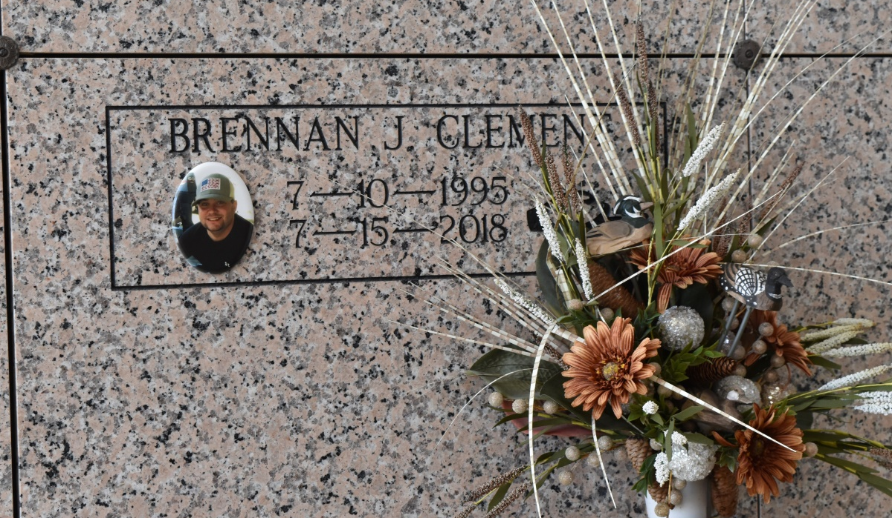

Brennan John Clement, 23, a native and resident of Vacherie, LA, passed away on Sunday, July 15, 2018. He was born July 10, 1995. He is survived by his mother, Yvette C. Alleman and husband Gerard "Bubba"; father, Bart Clement and fiancé Yvette Rome; sister, Shelby Clement Reulet and husband Josh; nephew, Aiden Reulet; maternal grandparents, Elton and Evelyn Hotard; maternal step-grandparents, Kevin and Clara Champagne, Lillian Percle Robertson; paternal grandparents, Raymond and Karen Delatte Clement; numerous aunts, uncles, and cousins. He is preceded in death by his special friend, Raini Scioneaux; cousin, Matthew Hotard; maternal grandparents, Kermit and Clothilde Kraemer, Eldon and Gladys Hotard; paternal grandparents, Thomas and Pearl Falgoust Delatte; adoptive great-grandmother, Florence "Nan" Falgoust Becnel; great-grandparents, Eddie and Irene Clement.
Unknown source
Contributed by Team T Lo

