Lloyd Louis Clement
May 3, 1925 – October 9, 2001

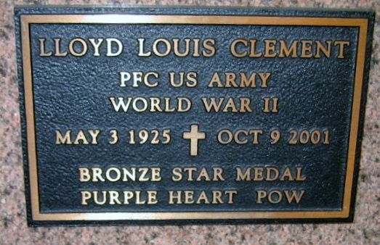
Photo by Bobby

VACHERIE - Lloyd Louis Clement, 76, a native of Chackbay and resident of Vacherie, died Oct. 9. He was the husband of the late Marie Cleophine Becnel Clement and father of Judith Bourgeois and Marilyn Morvant.
He was the son of the late Claude Sr. and Alcide Rose Clement and brother of Inez Becnel, Florence Matherne, Edward, Joseph "Jerry," George and Thomas Clement and the late Mildred Ockmond and Elizabeth, Nell and Claude Clement Jr.
He is survived by five grandchildren and two great-grandchildren.
Services were Oct. 12 at Our Lady of Peace Catholic Church, South Vacherie, with interment at the church cemetery.

L'Observateur (La Place, LA) - Sunday, October 14, 2001
Contributed by Jane Edson

