Morene Louis Cornelius Sr.
July 4, 1929 – January 25, 2000

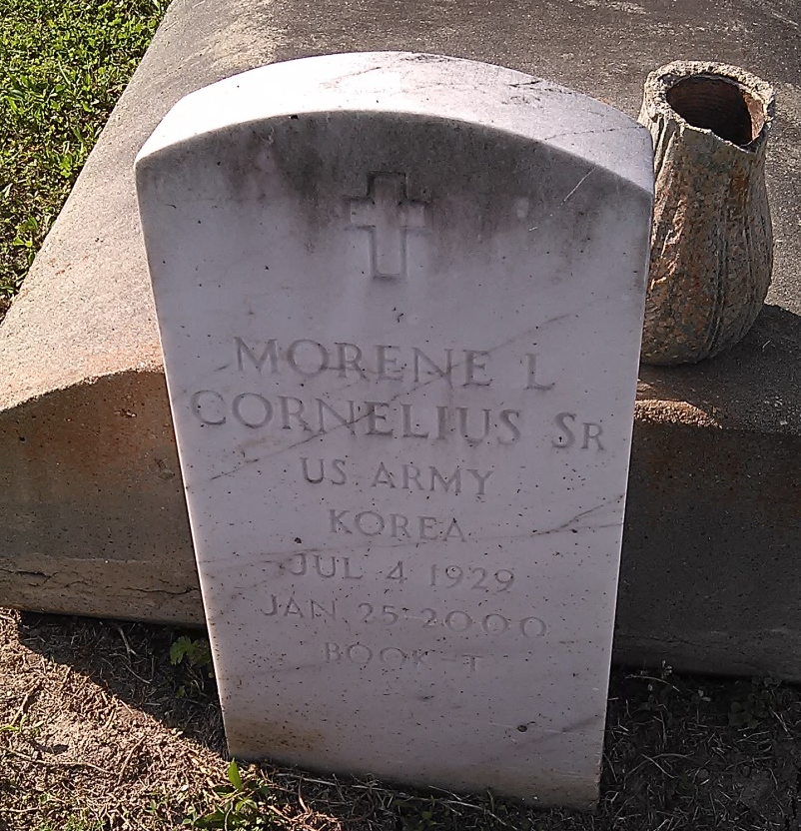
Photo by TMB

Morene Louis Cornelius Sr., a retired truck driver with the former D.H. Holmes Department Store, died Tuesday of complications from emphysema at Meadowcrest Hospital. He was 70. Mr. Cornelius was born in Vacherie and lived in Westwego for the past 28 years. He was a veteran of the Army. Survivors include his wife, Catherine E. Cornelius; two sons, Ronald and Morene L. Cornelius Jr.; two daughters, Cheryl C. Trotter and Andrea Taylor; three brothers, Clarence, Raynard and LeGrant Cornelius; three sisters, Doretha Tilquit, Eva Smith and Anna Mae Turner; and six grandchildren. A funeral will be held Saturday at 11 a.m. at D.W. Rhodes Funeral Home, 1716 N. Claiborne Ave. Visitation will begin Saturday at 9 a.m. Burial will be in Our Lady of Peace Cemetery in Vacherie.

Times-Picayune, The (New Orleans, LA) - Friday, January 28, 2000
Contributed by Jane Edson

