Celeste Marie (Rouge) Cortez
September 22, 1955 – June 14, 2017

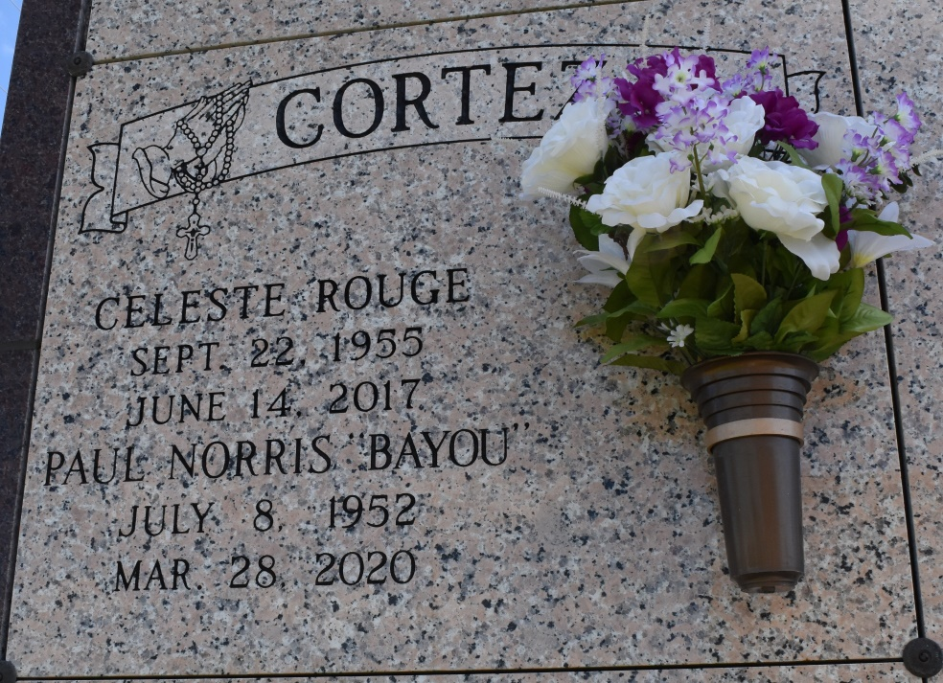

Cheryl H. Cortez, 48, born October 27, 1966. A native of Thibodaux and resident of Vacherie, died on Friday, March 27, 2015 in a boating accident. Visitation will be from 9AM until funeral time Wednesday, April 1, 2015 at Our Lady of Peace Catholic Church. A Mass of Christian Burial will be held at 12PM, at the church. Burial will follow in the church cemetery. She is survived by parents, Kenneth and Brenda Hebert; son, Trevor Simon, Jr.; step-daughter, Shawna Cortez; brother, Brett Hebert and wife Renise; niece, Renee Hebert; nephew, Brandon Hebert. She was preceded in death by her husband, Shawn Cortez; daughter, Courtney Simon; grandfathers, Allen Trosclair and Junius Hebert; grandmother, Rena Deslatte. Cheryl was an employee of St. James Parish Government, Elderly Services. She will forever be remembered for her genuine care of other people, her amazing cooking, her ability to brighten up any room she entered, and her gift of making everyone feel welcomed, cared for, and loved.
Thibodaux Funeral Home, Lafourche Parish, LA

