Linda (Tregre) Cortez
July 18, 1954 – September 22, 2017

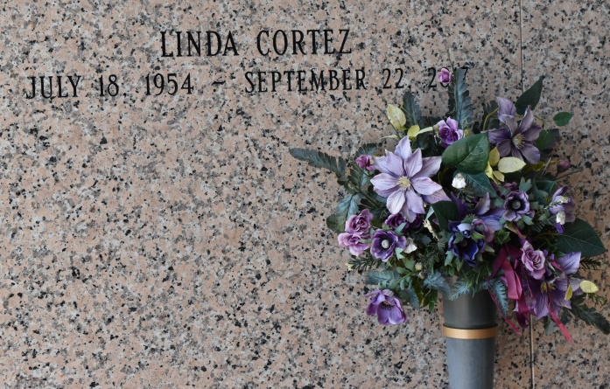

Linda Tregre Cortez born and raised in Vacherie, departed from this Earth in the early hours of Friday, Sept. 22, 2017, in the comfort of her own home. She was a graduate of St. James High.
Linda was preceded in death by her father and mother, Remy and Frosine Tregre; her husband, Lancy; brothers, Alexander, Edward, and Horace; and her sister, Ester.
She is survived by her beloved sons and daughters-in-law, Sean and his wife, Shannon Lasserre-Cortez along with Lance and his wife, Crystal Cortez. Her surviving sisters, Cecile, Clarabelle, and Thelma; and her grandchildren in which she had so much pride in and enthusiasm, Grace, Margaret, Jackson, Eleanor, Colin, and Alexis. She is also survived by her long-term partner and companion, Timmy Guidry Sr.
Linda enjoyed dancing, holidays, family gatherings, a bit of bingo and photography. She will be missed but not forgotten. "Regards to St. Peter as Linda arrives at his gates with her determined spirit that characterized her life."
A visitation will be held on Monday, Sept. 25 at Our Lady of Peace Catholic Church in Vacherie, from 8:30 a.m. until funeral time. A Mass of Christian Burial will take place at 11 a.m. Interment will follow in the church cemetery.
Thibodaux Funeral Home Inc. is in charge of arrangements.

Houma Today, Terrebonne Parish, LA
Sep. 22 to Sep. 23, 2017

