Paul Norris Cortez
July 8, 1952 - March 28, 2020

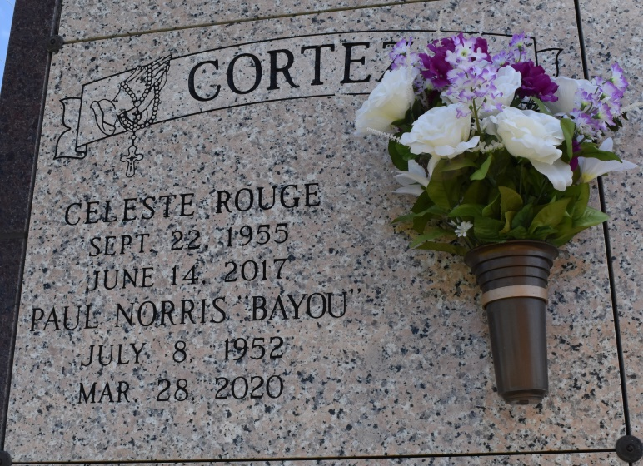

Paul Norris "Bayou" Cortez, 67, a native of Kraemer and a resident of Vacherie, passed away on Saturday, March 28, 2020 at Thibodaux Regional Medical Center.
He is survived by his son, Lucas Cortez; daughter, Andrea Cortez; two grandchildren, Shawna Cortez and Jaidan Cortez; two sisters, Emma Rome and Shirley Landry Hebert; and a host of nieces, nephews, and friends.
He was preceded in death by his wife, Celeste R. Cortez; son, Shawn Paul Cortez; parents, Joseph F. Cortez and Elvire U. Cortez; siblings, Tracy Cortez, Laura Cedotal, and Charles Cortez.
Bayou was a loving person. He never met a stranger, and valued his family. He was very generous and helped many people. He greatly enjoyed the outdoors, and cooking for family and friends.
Due to certain circumstances, a private service will be held; please join us in spirit. A celebration of his life will be held at a later date.
Online condolences can be given at www.thibodauxfuneralhome.com.
Thibodaux Funeral Home
Lafourche Parish, Louisiana

