Chad William Delatte
September 28, 1968 – August 7, 1970

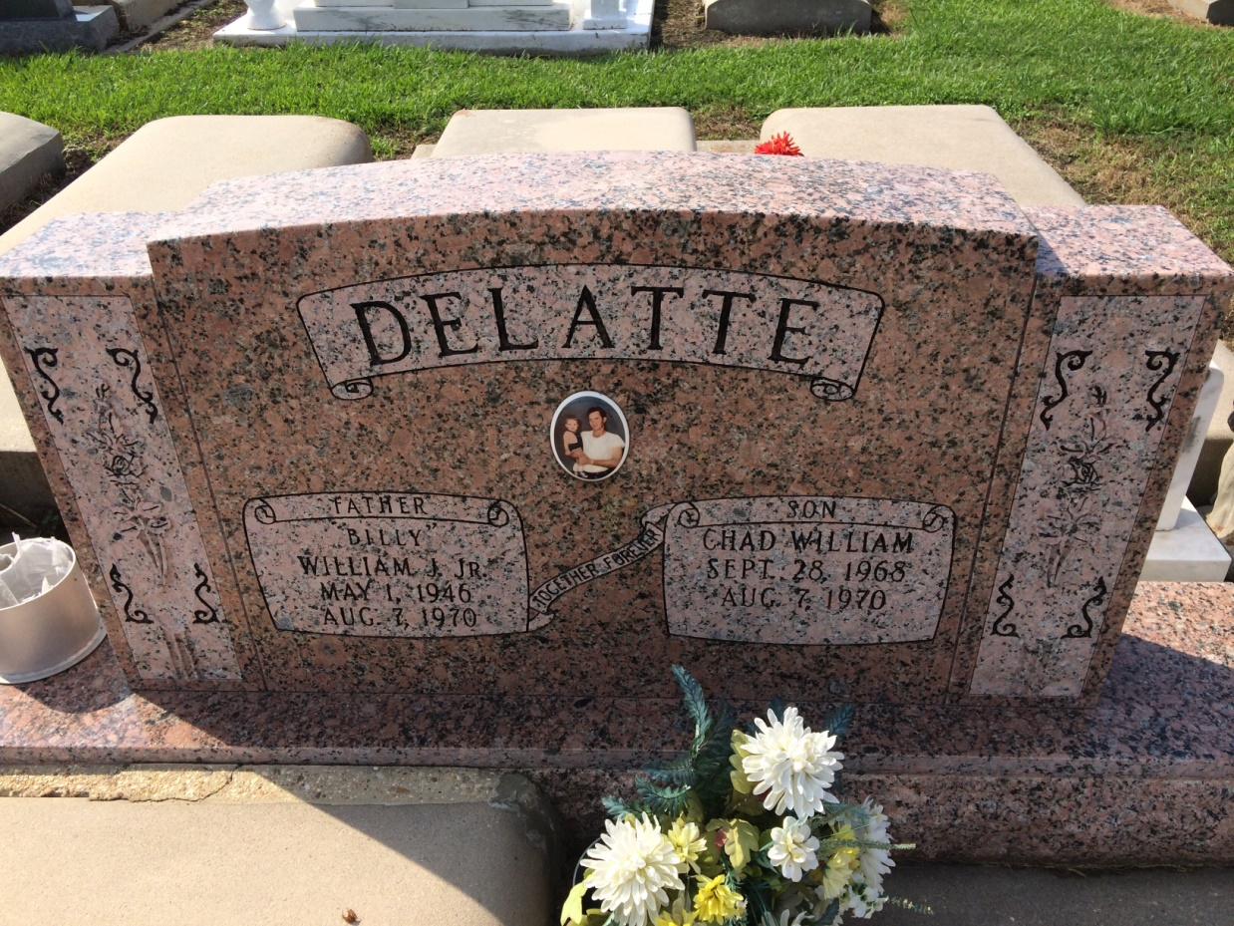
Photo by Kerry Keller

Chad William Delatte, on Friday, August , 1970, at 4:15 o’clock p.m.; son of Dollie Winters Delatte and the late William J. Delatte Jr.; brother of Mark Anthony Delatte; grandson of Mrs. And Mrs. William J. Delatte Sr. and Mr. and mrs. B. F. Winters Sr.; age 1 year and 10 months. Relatives and friends of the family are invited to attend the funeral. Services from Knights of Columbus Home, Vacherie, Louisiana, on Monday, August 10, 1970, at 9:30 o’clock a.m.; followed by Requiem High Mass at Our Lady of Peace Catholic Church, Vacherie, Louisiana at 10 a.m. Interment in Our Lady of Peace Cemetery. Arrangements by Landry’s Funeral Home, Thibodaux, Louisiana
Unknown newspaper clipping
Contributed by Anne Davis

