Donald Paul Delatte Jr.
March 28, 1947 – January 9, 2011

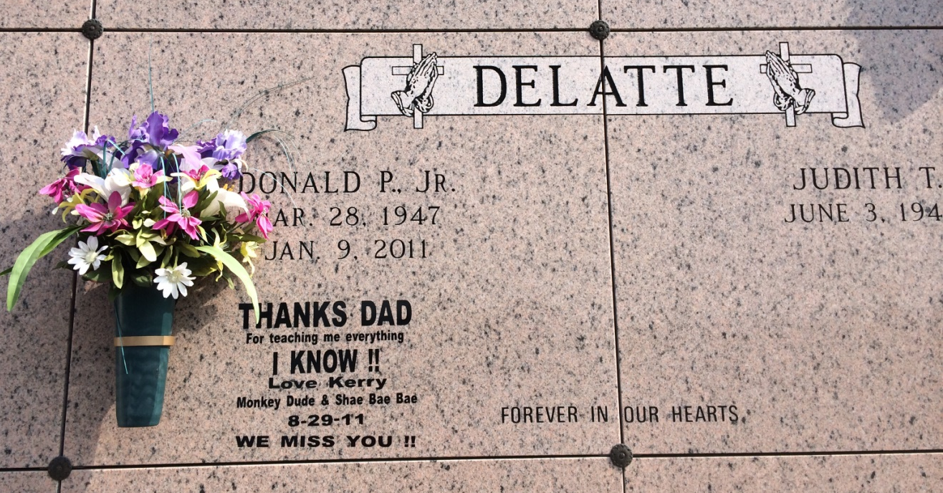
Photo by Kerry Keller

A hush fell over the marsh on Sunday, Jan. 9, 2011, as Donald P. "Donnie" Delatte Jr. put away his pirouge and fishing poles and went home to be with his parents, Donald Sr. and Cecilia.
Visitation was from 8 a.m. to funeral time today at Our Lady of Peace Church in Vacherie. Mass was held at 10 a.m. today at the church, with interment in the church cemetery.
He leaves behind his devoted wife of 44 years, Judith "Judy" Torres Delatte; and his children, Kevin and wife, Shannon, Becki and Kerry. The lights of his life William, Hailey, Spencer and Shae will forever shine brighter for having him as their grandpa. He also leaves behind his wonderful "Pop" Clarence Loup; four brothers, Bruce and wife, Charlotte, Kenneth and wife, Marsha, Brian and wife, Clair, and Frankie and wife, Stacy; and his treasured godchildren, nieces, nephews and a lifetime of close friends.
A very special thank you to all who helped care for him while on his journey home.
In lieu of flowers, donations can be made to the American Cancer Society.
Falgout Funeral Home is in charge of arrangements.
[Father: Donald Paul Delatte (1927 - 1991)]

Unknown source

