Cecilia Anne (Waguespack) Delatte Loup
April 24, 1927 – September 12, 2009

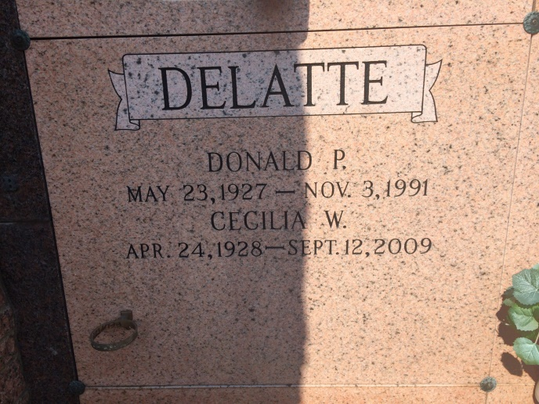
Photo by Kerry Keller

Cecilia Delatte Loup, age 81, a resident of Vacherie, LA and native of Wallace, LA, died on Saturday, September 12, 2009 at 10:00 PM. Survived by husband, Clarence G. Loup; 5 sons, Donald P. Delatte Jr. and wife Judy, Bruce A. Delatte and wife Charlotte, Kenneth J. Delatte Sr. and wife Marsha, Brian J. Delatte and wife Claire, Frankie Delatte Sr. and wife Stacy; 1 brother, Malvin Waguespack; 14 grandchildren and 12 great-grandchildren. Preceded in death by husband of 45 years, Donald Paul Delatte Sr.; parents, Adelta and Drazan Waguespack; and great-grandchild, Anna Grace.
She was a parishioner of Our Lady of Peace and was a member of the Ladies Altar Society and the perpetual adoration chapel. She loved fishing, traveling, going to the casino and sewing.
Visitation from 8:00 AM until 11:00 AM on Monday, September 14, 2009 at Our Lady of Peace, Vacherie, LA. Mass of Christian Burial at 11:00 AM on Monday, September 14, 2009 at Our Lady of Peace, Vacherie, LA. Interment Our Lady of Peace.
Arrangements under the direction of Falgout Funeral Homes, Inc. of Raceland.

Times-Picayune, The (New Orleans, LA) - Monday, September 14, 2009
Contributed by Jane Edson

