Rita (Marse) Delatte
September 11, 1922 – November 18, 2007

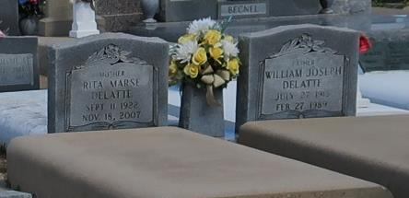

Rita Marse Delatte, 85, a native and resident of Vacherie, La., died Sunday, November 18, 2007, at 3:40 a.m.
She is survived by her two sons, Barry Delatte and his wife Carol and Larry Delatte and his wife Nadine; two daughters, Enola Waguespack and her husband Terrell and Suzanne Rome and her husband Alfred; one brother, Bernard Marse; three sisters, Bernadette Tregre and her husband Alcide, Claire Gauthreaux and her husband Ed, and Tee Hymel and her husband Kelsey; 14 grandchildren; and 19 great-grandchildren.
She was preceded in death by her husband, William Delatte; her parents, Severas and Procla Falgoust Marse; one son, Billy Delatte; three brothers, Leonard Marse, Augustin Marse, and Severas Marse, Jr.; and two grandchildren, Debra Waguespack and Chad Delatte.
Visitation is Tuesday, November 20, 2007, from 9:00 a.m. until 11:00 a.m., with the funeral to follow at Our Lady of Peace Catholic Church in Vacherie. She will be buried in the church cemetery.
Rose Lynn Funeral Services is in charge of the arrangements.

Houmatimes.com
November 20, 2007

