William J. Delatte Jr.
May 1, 1946 – August 7, 1970

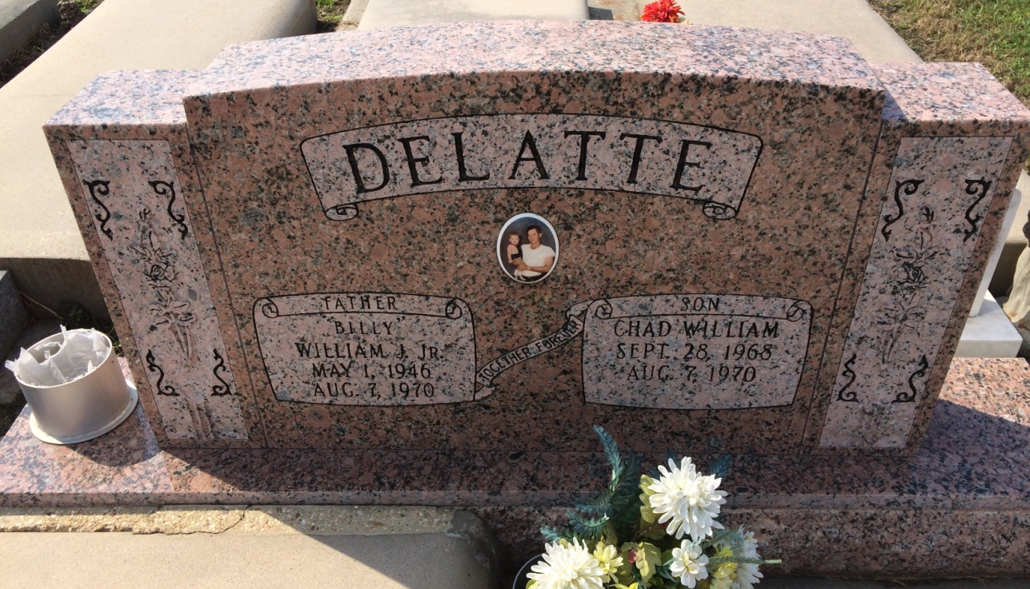
Photo by Kerry Keller

William (Billy) J. Delatte Jr., on Friday, August 7, 1970, at 4:15 o’clock p.m., husband of Dollie Winters Delatte, father of Mark A. Delatte and the late Chad W. Delatte, son of William J. Delatte, Sr., and Rita Marse, son-in-law of Mr. and Mrs. B. F. Winters, Sr., brother of Barry, Larry and Suzanne Delatte and Mrs. Farrell Waguespack, age 24 years. Relatives and friends of the family are invited to attend the funeral. Services from the Knights of Columbus Home, Vacherie, La. on Monday, August 10, 1970 at 9:30 o’clock a.m. followed by Requiem High Mass at our Lady of Peace Catholic Church, Vacherie, La. at 10 a.m. Interment in Our Lady of Pearce cemetery. Arrangements by Landry’s Funeral Home, Thibodaux, La.

Times-Picayune, New Orleans, LA; August 10, 1970
Contributed by Ann Davis

