Gilbert Joseph Dempster
April 28, 1962 – May 30, 2005

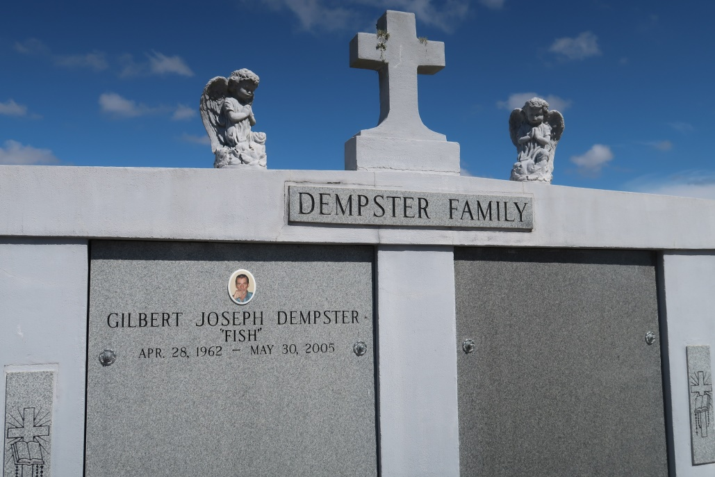

Dempster, Gilbert Joseph "Fish"

A resident and native of Vacherie, he died at 1 p.m. Monday, May 30, 2005. He was 43, born April 28, 1962. Visitation at Thibodaux Funeral Home, Thibodaux, from 6 p.m. to 10 p.m. Wednesday, June 1. Visiting at Our Lady of Peace Catholic Church, Vacherie, on Thursday, June 2, from 8 a.m. until Mass of Christian Burial at 11 a.m. Interment in Our Lady of Peace Cemetery. He is survived by his parents, Melford E. Dempster Jr. and Joan C. Dempster; three brothers, Randal, Roy and Ron Dempster, all of Vacherie; and two sisters, Pamela D. Falgoust of Vacherie and Annette D. Lisle of Georgia. Preceded in death by his grandparents, Melford Dempster and Leonise Dempster and Gilbert Cortez and Noelie Cortez. He was employed by the Lafourche Basin Levee District for 20 years.

Advocate, Baton Rouge, LA
June 1, 2005

