Janice (Dumas) Dickerson
February 21, 1937 – September 15, 2016

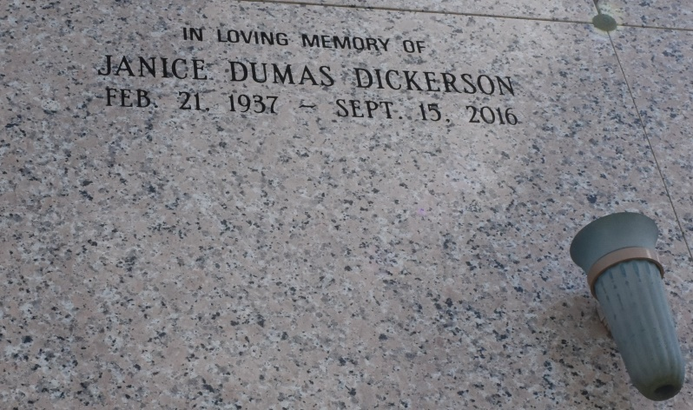

On Thursday, September 15, 2016, Janice "Nanny" Dumas Dickerson transitioned to her heavenly home at the age of 79.
She leaves to cherish her memory, children-Donna Dickerson Kearse (Hasten) and James Phillip Dickerson, Jr.; granddaughter, Elise Fabregas (Pedro) and great granddaughter, Skylar Fabregas; two sisters, Mercidee Dumas Favarote( Joseph) and Julia Dumas Lindsey (Mose), both of New Orleans, LA; seven brothers, Melvin, Sr. (Ruth), Eliszy, Jr. (Brenda) and Dave Dumas of Vacherie, LA, Anthony and Michael (Mary) of Los Angeles, CA, Bertrand (Pam) and Martin Dale Dumas (Troy) of New Orleans, LA. She also leaves to cherish her memory, a host of nieces, nephews, cousins, other relatives and friends. Janice was a faithful and longtime member of New Hope Baptist Church. She was preceded in death by her parents, Eliszy Sr. and Odile Dumas.
Relatives and friends of the family; Pastor, Officers and members of New Hope Baptist Church are invited to attend the service. A Funeral will be held at New Hope Baptist Church, 1807 John Raphael Jr. Way (formerly LaSalle St.) on Saturday, September 24, 2016 at 11 AM, Pastor Jamaal Weathersby, Officiating. Interment Our Lady of Peace Cemetery, Vacherie, LA. Visitation 10 AM IN THE CHURCH. Charbonnet Labat Glapion, Directors (504)581-4411

The Times-Picayune, New Orleans, LA
Sep. 21 to Sep. 23, 2016

