Henry Domino
January 6, 1938 – November 26, 2017

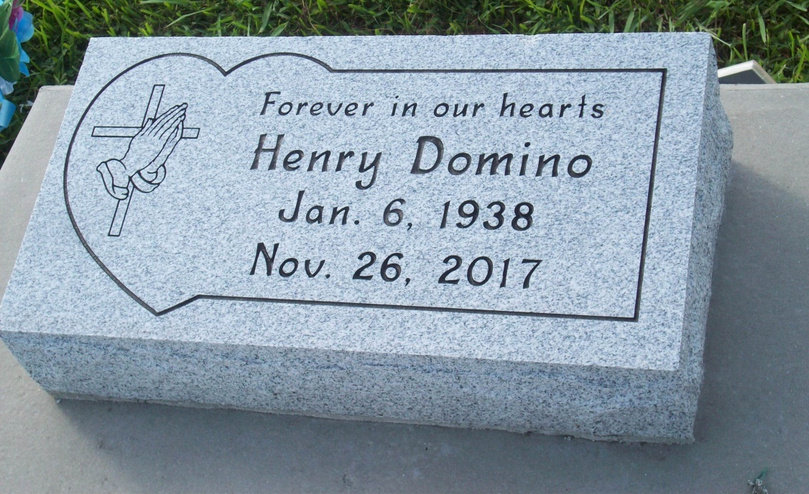
Photo by TMB

HENRY "HORSE" DOMINO: He departed this life on Sunday Nov. 26, 2017 at Thibodaux Healthcare Center in Thibodaux, LA. He was 79, a native and resident of Vacherie, LA. Visitation on Friday, Dec. 1, 2017 at Our Lady of Peace Catholic Church, Vacherie, LA from 12:00am to the Mass of Christian Burial at 2:00pm. Burial in the church cemetery. Survived by his wife, Rosemary Domino of Vacherie, LA; 1 son, Corey (Tara) Domino of Houma, LA; 1 daughter, Robin Landry of Vacherie, LA; 2 sisters, Marcella Octave, and Melodie Dumas of Vacherie, LA; 2 brothers, Horace Domino, Sr., and Macklin Domino, Sr. of Vacherie, LA; Also 10 grandchildren, 12 great grandchildren, 1 great, great, grandchild, and a host of nieces, nephews, other relatives and friends. Preceded in death by his parents, Julia and Horace Domino, Sr.; 1 daughter, Joyce Reynolds; 1 grandchild, Ashley Landry.

Unknown source

