Julia (Freeman) Domino
August 9, 1914 – March 29, 2004

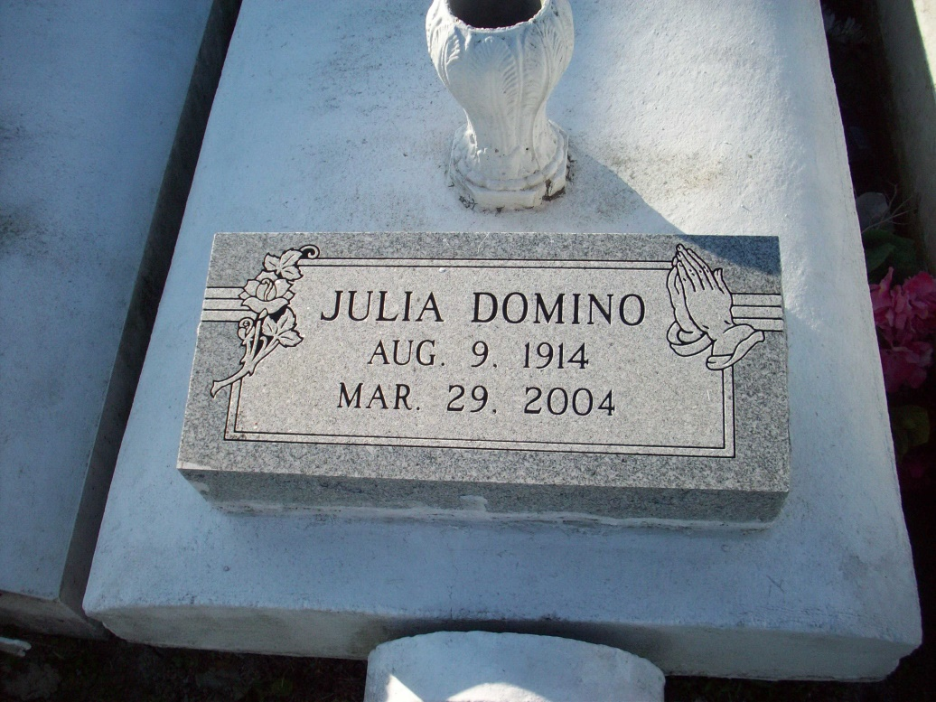
Photo by TMB

Julia Freeman Domino, 89, a native and resident of Vacherie, died March 29, 2004.She is survived by her sons, Henry J. Domino, Horace J. Domino Jr., and Macklin J. Domino Sr., all of Vacherie; daughters, Melanie D. Dumas, and Marcella M. Octave of Vacherie; brother, Joseph Octave Freeman of Marrero; sister, Melanie F. Dumas of Vacherie; 16 grandchildren; 23 great grandchildren; and four great-great-grandchildren. She was preceded in death by her husband, Horace Domino Sr.; parents, Alcee Freeman Sr., and Melanie Steib; brother, Alcee Freeman Jr., sisters, Agnes F. James, and Veronica F. Keller; and one great granddaughter. She was a parishioner of Our Lady of Peace Catholic Church.

Unknown source

