Norine (Oubre) Domino
October 11, 1907 – May 21, 1997

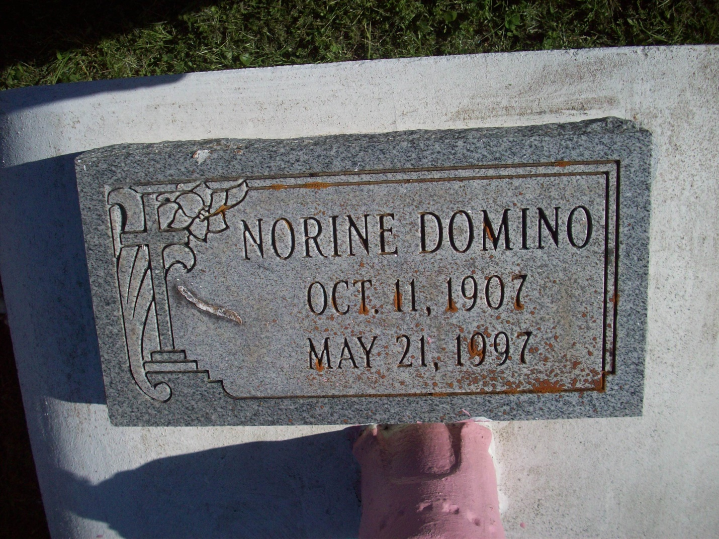Photo by TMB

Norine O. Domino, a homemaker, died Wednesday May 21, 1997 at St. Charles Manor Nursing Home in Vacherie. She was 90. Ms. Domino was a lifelong resident of Vacherie. Survivors include a daughter, Leona Domino Hodges; four brothers, Freddie, Joseph O. and Amelise Oubre Jr. and Ersin Oubre Sr.; two sisters, Amie O. Narcisse and Katherine Oubre; eight grandchildren; and 11 great-grandchildren.

Unknown source

