Sheila Domino
July 11, 1944 – November 11, 2011

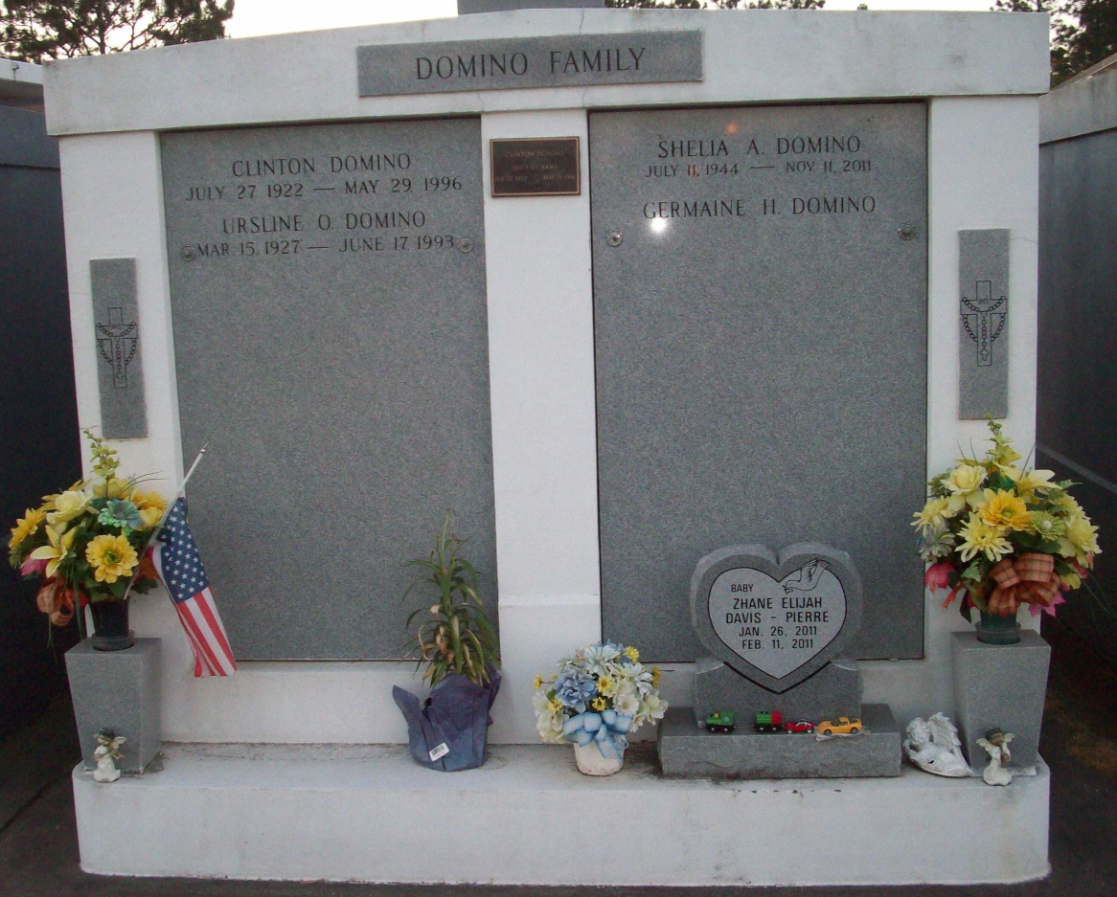
Photo by TMB

Sheila Domino, a retired elementary school teacher, died Friday, Nov. 11, 2011, at Thibodaux Regional Medical Center. She was 67 and a native and resident of Vacherie. Visiting at Our Lady of Peace Catholic Church, 13281 La. 644, Vacherie, Saturday, Nov. 19, from 7 a.m. until religious service at 10 a.m., conducted by the Rev. Louis T. Oubre. Burial in the church cemetery. She is survived by her sister, Germaine H. Domino-Laurent; brother-in-law, Keith A. Laurent; and a host of other relatives and friends. She was preceded in death by her parents, Clinton and Ursline Oubre Domino; paternal grandparents, Donation and Noelie Osborne Domino; and maternal grandparents, Walter and Ollie Steib Oubre.

Unknown source

