Albert Dumas
February 19, 1938 – May 9, 2002

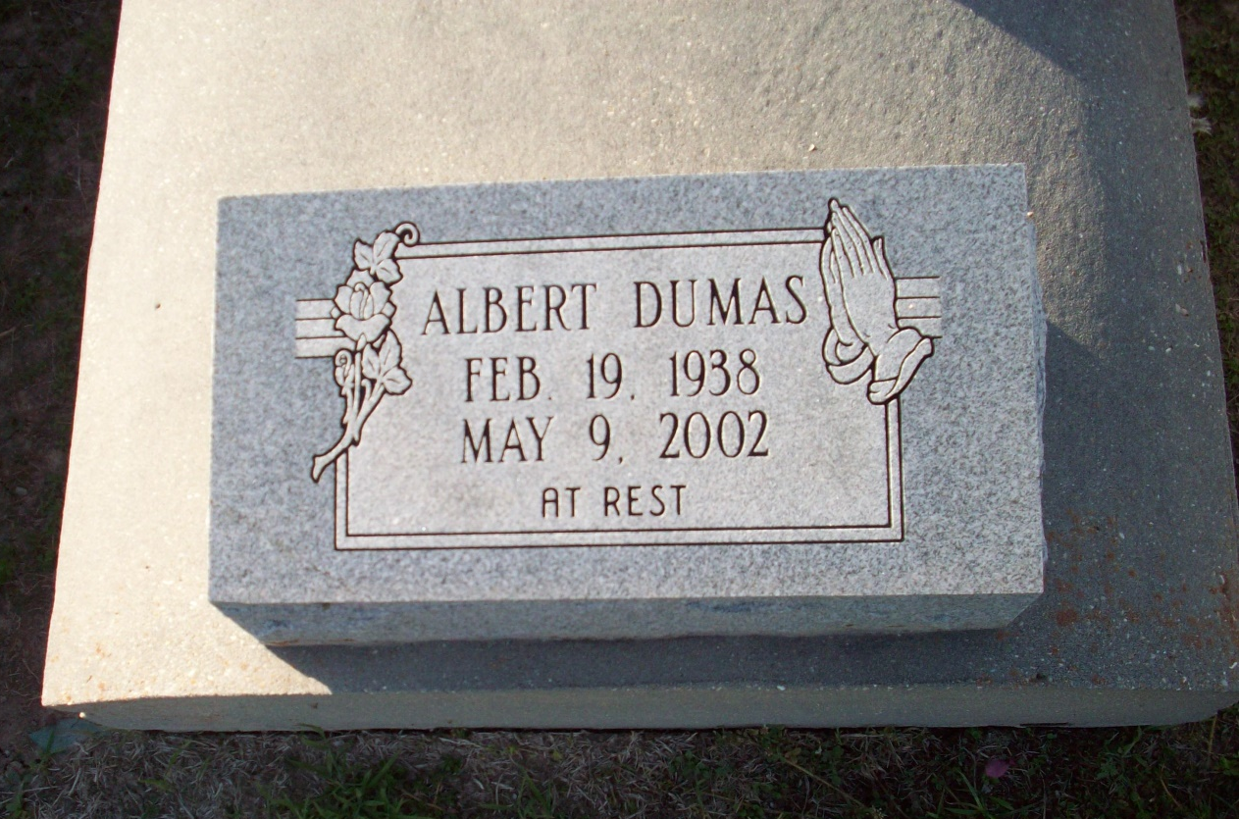
Photo by TMB

Albert Dumas passed on Thursday, May 9, 2002, At Thibodaux Regional Medical Center. Son Of The Late Mary And Joshua Dumas, Sr. Brother Of Eliven Phillips, Diane Simoneaux, Julia Bailey, Eugene, Simon, Joshua, Jr. And Dennis Dumas, Sr. All Of Vacherie, La, Mable Bailey Of Edgard, La And Joseph Austin Dumas Of Las Vegas, Nv. Also Survived By A Host Of Aunts, Uncles, Nieces, Nephews, Other Relatives And Friends. A Native And Resident Of Vacherie, La. Age 64 Years. Relatives And Friends Of The Family Are Invited To Attend The Mass Of Christian Burial On Saturday, May 18, 2002, At 10:30am From Our Lady Of Peace Catholic Church, South Vacherie, La. Interment In The Church Cemetery.

Unknown source

