Bonnie Francis (Dumas) Dumas
June 8, 1955 – November 10, 1995

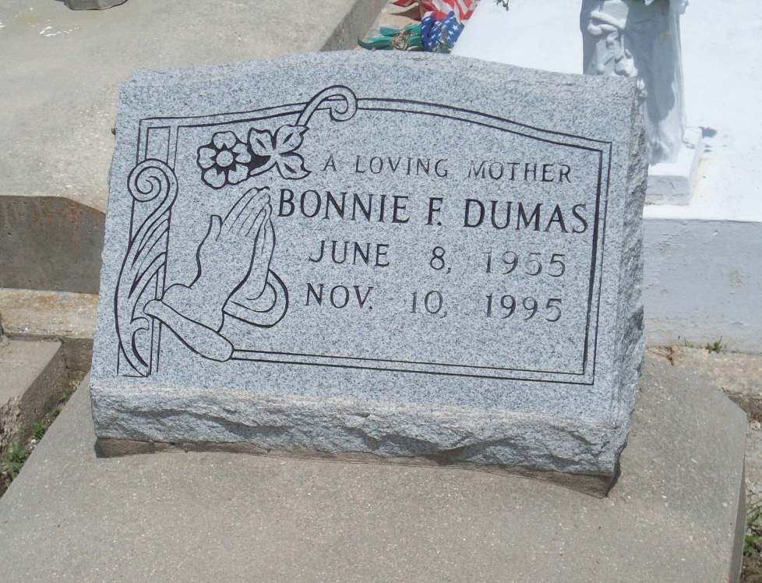
Photo by TMB

Bonnie Francis Dumas, a homemaker, died Friday of cancer at her home. She was 40. Mrs. Dumas was a lifelong resident of Vacherie. She was a graduate of St. James High School and Southern University and a member of the Word of Christian Life Center in Darrow. Survivors include her husband, Nathan Dumas Sr.; two sons, Nathan Jr. and Blair Dumas; her mother, Dolores Dumas; six brothers, Randy Dumas of Inkster, Mich., Ignatius Dumas of Newport News, Va., Virgil Dumas of Thomasville, Ga., Phillip Dumas of Watertown, N.Y., and Warner and Harry Dumas; and three sisters, Ronna Rhodes of Thibodaux, Robin McLee of Tucson, Ariz., and Donna Dumas of Upper Marlboro, Md.

Unknown source

