Edwin Dumas
June 26, 1929 – October 11, 2004

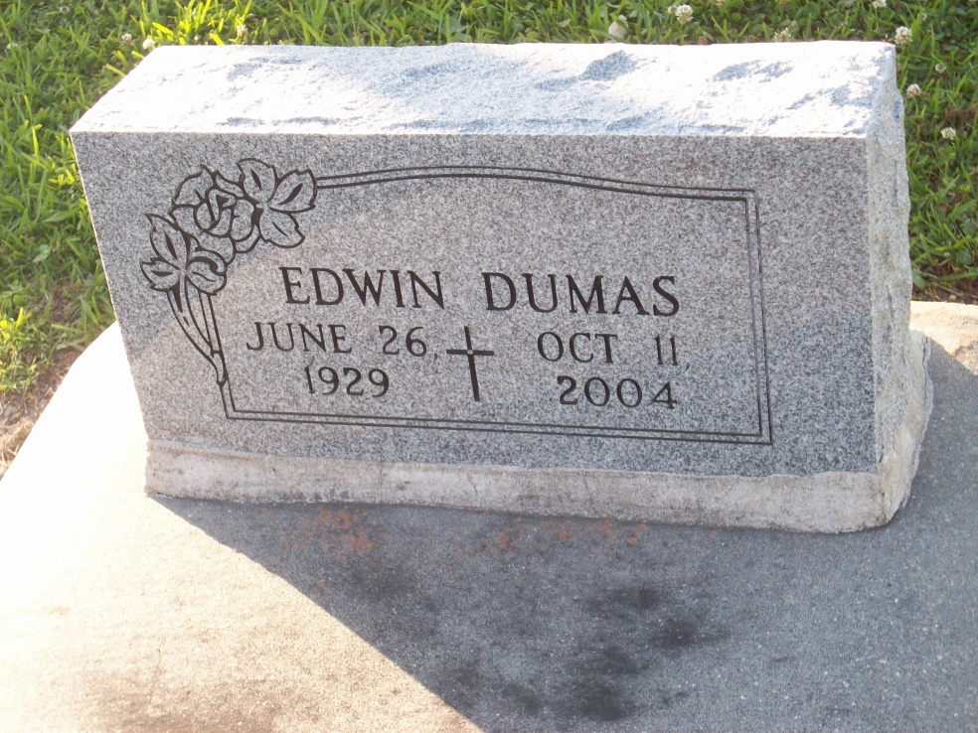
Photo by TMB

Edwin Dumas, died on Monday, October 11, 2004. A visitation will be held at D.W. Rhodes Funeral Home, 3933 Washington Ave. on Friday, October 15, 2004 from 6:00 pm until 8:00 pm. A Funeral Mass of Christian Burial will be held at Our Lady of Peace Catholic Church, Highway 644, Vacherie, LA. Interment Church Cemetery.
Arrangements by D.W. Rhodes Funeral Home, 3933 Washington Ave.

Times-Picayune, The (New Orleans, LA) - Friday, October 15, 2004
Contributed by Jane Edson

