Eva (Louis) Dumas
March 18, 1895 – April 18, 1986

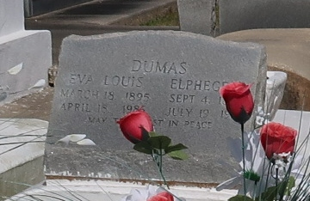

A Mass of Christian Burial was to be held today at 11 a.m. from Our Lady of Peace Catholic Church in Vacherie for Eva Louis Dumas who died Friday (April 18, 1986) at 6:25 a.m. She is survived by daughters Essie Thornton and Cecilia Esteen, both of New Orleans and Maude Lemieux, Priscilla Gros, Velma Calloway, Helen Jeffery and Lois Batiste, all of Vacherie; a brother Bernard Dumas of Vacherie; a sister, Geneva Dixon of New Orleans; 48 grandchildren; 79 great-grandchildren; and nine great-great grandchildren. She was the guardian of Clerita Rapheal, Paulette Smith, Joelle Seymour, Fedricka Calloway, and Acquanette, Christine and Eva James [dtrs. of Eva Dumas James]. She was preceded in death by her husband Elphege Dumas; her parents Antoine and Adele James Louis; sons Ralph, Claude and Eddie Dumas; a daughter, Eva James, sisters Cleonas Wood, Eve Davis and Gladys Dumas; and brothers Antoine, Edward, Joseph and Harry Louis. Interment was in Our Lady of Peace Catholic Church Cemetery in Vacherie.
SchexDumas Ancestry
Contributed by RV Schexnayder

