Gerald Anthony Dumas
December 16, 1967 – October 3, 2009

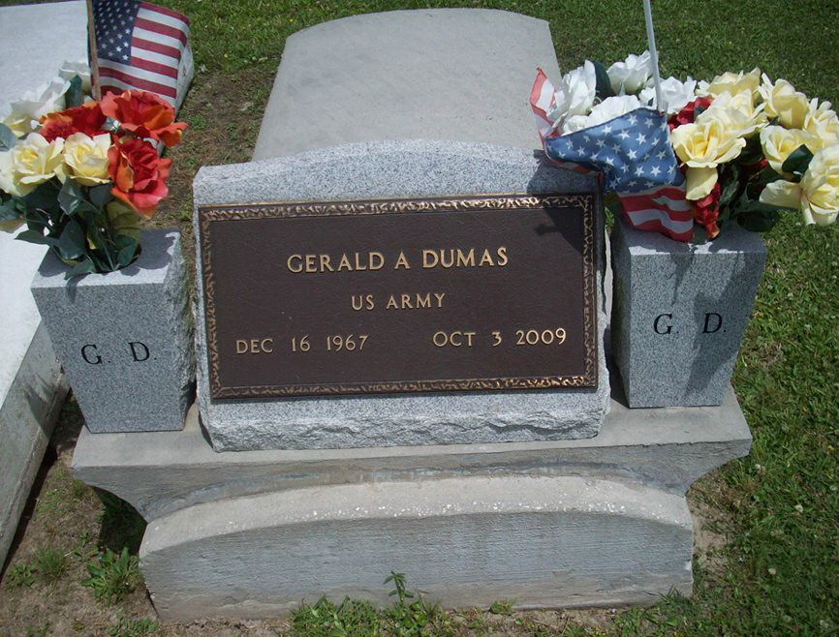
Photo by TMB

GERALD ANTHONY DUMAS: An employee of Honeywell and RainC11 corporations, he died on Saturday, Oct. 3, 2009. He was 41, a native and resident of Vacherie, LA. Survived by his parents, Agnes and Henry Dumas, Jr.; His children, Aviahn, Daminet, Brandon, Jeremiah and Tierney; 2 sisters and spouses, Darlean and Rapheal Simon, Trina and Emmanuel Burke; 1 brother and spouse, Elliott and Karen Wooley; a devoted friend, Debra Johnson of Houma, LA and a host of aunts, uncles, nieces, nephews, other relatives and friends. He was a 1985 graduate of St. James High School, an ITT Technical School honor graduate, and a veteran of the U.S. Army.

Unknown source

