Hayward Joseph Dumas
November 10, 1928 – July 11, 2002

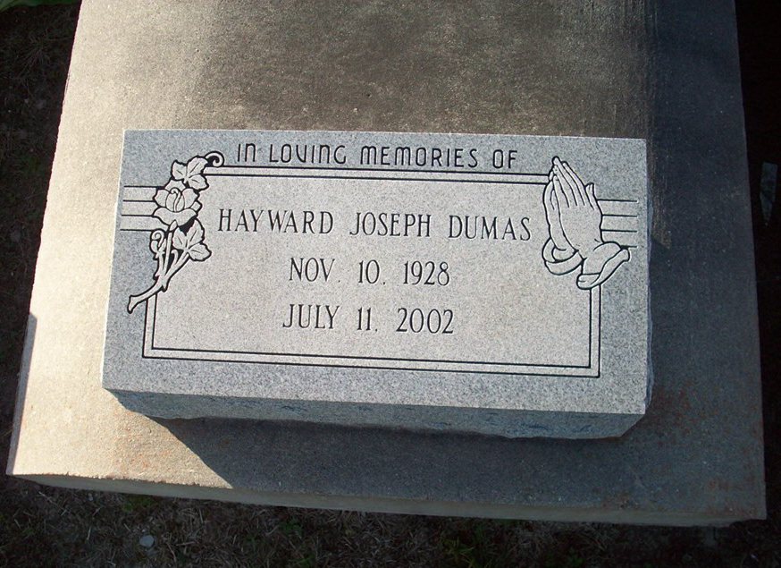
Photo by TMB

Hayward Joseph Dumas Departed This Life At West Jefferson Medical Center on Thursday, July 11, 2002 At 8:00 P.M. Husband Of The Late Florence Robinson Dumas. Father Of Ronald Dumas Of Avondale, La, Brenda A. Dumas Of Gretna, La And Carolyn D. Rancifer Of Marrero, La. Grandfather Of Quentin, Rondell, Christopher, Dominique And Rhonda. Great-Grandfather Of Sean Michael Dumas. Son Of The Late Paul B. And Rose Osborne Dumas. Brother Of Leo Paul, Whitney, Anthony And Russell Dumas,Wilberine Steib, Mary Freeman, Victorine Simon, Celeste James, The Late Agnes Wooden, Harry And John Dumas. Father-In-Law Of The Ike Rancifer. Also Survived By A Host Of Nieces, Nephews, Sisters-In-Law, Brothers-In-Law, Cousins, Other Relatives And Friends. Age 73 Years. A Native Of Vacherie, La And A Resident Of Marrero, La.

Unknown source

